Appendix 2: Longitudinal Changes in Perceived Power and Trust Assessments
Extending on the summary of power and trust scores in section 4.4, this appendix section provides additional detail on how participants’ perspectives changed throughout their participation. Looking deeper into the changes in power and trust summaries in Figure 4, distinct changes in attitude were observed from reviewing the privacy policy as well as from experiencing the GDPR process and from discursive review of GDPR responses. Figures 5 and 6 show snapshots of power and trust ratings at different points in the process across all data holders which illustrate these separate impacts.
Looking to explain these changes qualitatively, we observe that privacy policies often contradicted participants’ expectations, resulting in discomfort. In two cases (Philips Hue and last.fm) privacy policy review revealed that the service relationship was with a completely different company than the participant thought, which was disturbing. LinkedIn’s privacy policy was noteworthy as being exceptionally clear, reassuring and trust-enhancing to the participant, largely due to its ‘easy read’ text sidebars but also good use of examples. Google’s privacy hub with its video explainers was considered easy to understand but, given the breadth of their product and service offerings, necessarily broad. This led to it being considered over-simplified, raising uncertainty about generalisations made, and in some cases increasing distrust.
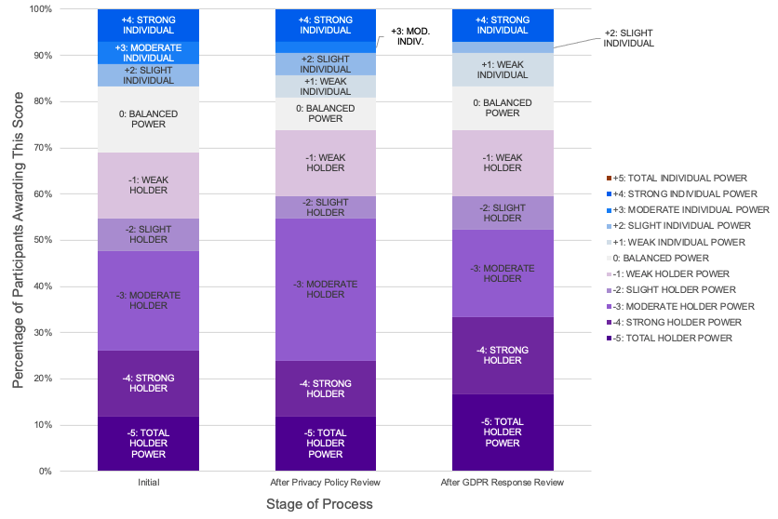
Figure 5: Perceived Power Balance Between Individual and Data Holder at Different Stages of the GDPR/Study Process
Considering the process as a whole, participants’ attitudes were impacted particularly by the “hassle” (P11) they experienced in getting through the data access process, and from the realization that what seemed at first glance to be a thorough response, when examined more deeply in Interview 3 and viewed through the lens of the privacy policy promises and one’s GDPR rights to the five categories of data, was in fact quite poor.

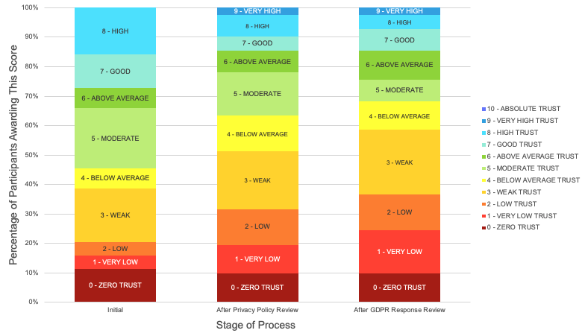
Figure 6: Participants’ Perceived Trust in Provider at Different Stages of the GDPR/Study Process

