Seeing the future: predictive and classical control in neural models of ocular accommodation

Jenny C. A. Read¹, Christos Kaspiris Rousellis¹, Bing Wu², Björn Vlaskamp², Toby S. Wood³, Clifton M. Schor⁴
Simulink models and Matlab code
The Simulink model implementing the model described in the paper is AccommodationModel.slx.
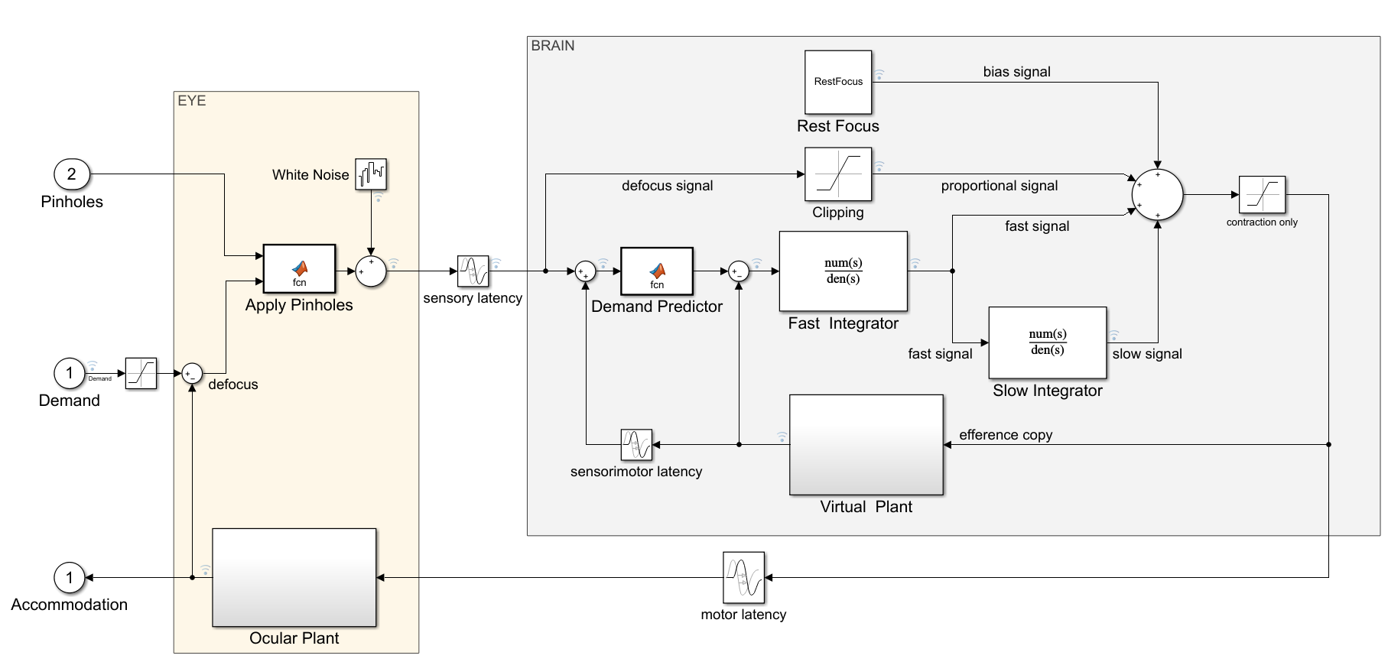
The model has two inputs: (1) accommodative demand in diopters, and (2) “pinholesON”, which conveys whether pinholes are currently applied or not. If they are, the defocus is set to zero; otherwise it is set to demand minus accommodation.
The model parameters can be viewed and altered in the Model Workspace:

The three Expt_....slx files provide appropriate input to this model, e.g. Expt_Sine.slx provides sinusoidal demand with no pinholes.
To get the results shown in the paper, run the code specified in each figure legend. E.g. for Figure 12, first open Matlab and run the program Run_Sine.m (e.g. by changing to the correct directory and typing Run_Sine in the Matlab command window). This runs simulations using the Simulink models Expt_Sine.slx and AccommodationModel.slx, and saves the results in Results_Sine.mat. These can then be plotted with Fig_CompareGainPhase.m.

