eFigure 1. Number of patients evaluated for safety and efficacy in Koga et al. 2018 ¹
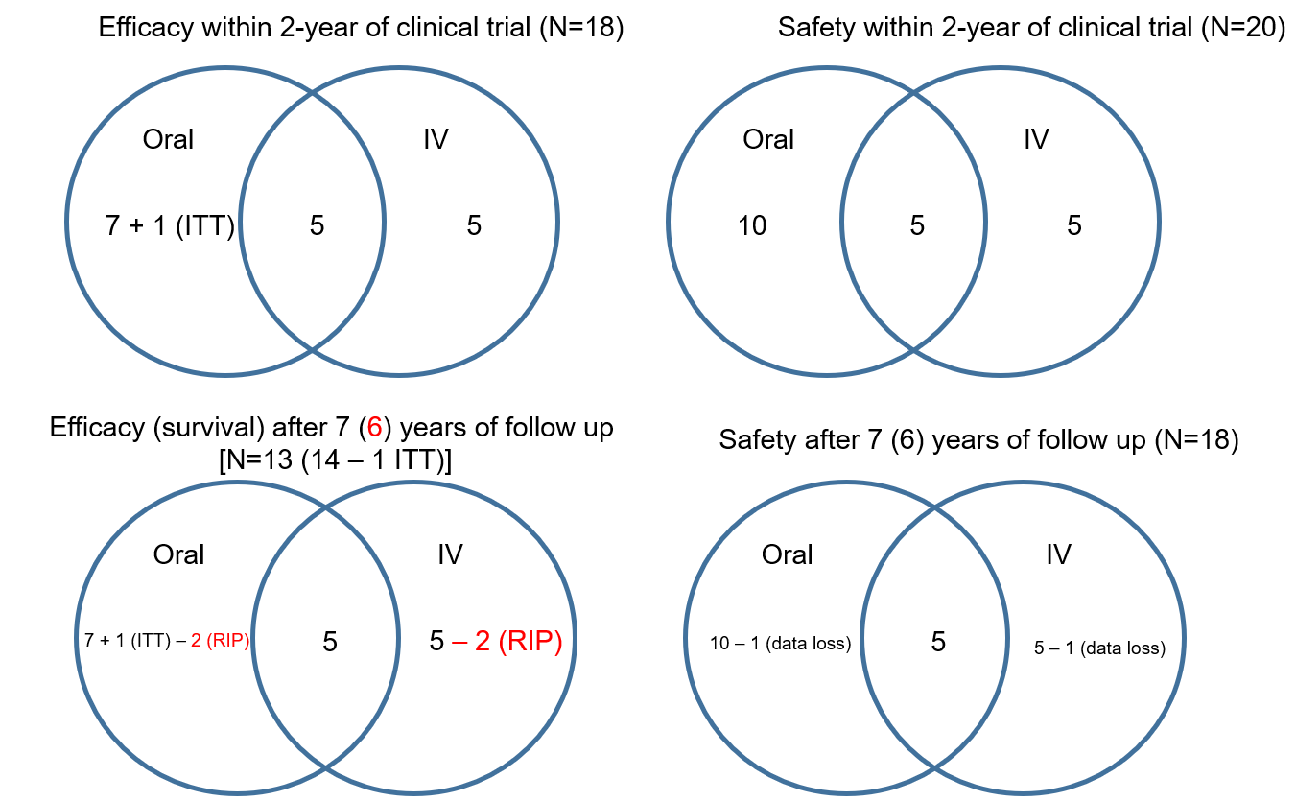
B
A

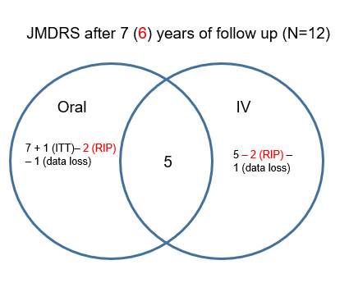
C

Abbreviations: ITT, intention-to-treat; JMDRS, Japanese mitochondrial disease rating scale; RIP, rest in peace

A Inter-ictal MELAS (Oral) March 09–June 11, a
N=15 patients were enrolled. N=3 patients discontinued: increased seizure frequency, concurrent pneumonia, and unverified efficacy.
Efficacy: N=13, However N=12 completed the trial [data from 1 of the 3 discontinued patients was included for analysis (assumed ITT)]
Safety: N=15
a 5 patients were also enrolled in the clinical trial of IV L-arginine

B Acute MELAS (IV) Dec 08–March 2011 b
Enrolment (N=10); Efficacy (N=10); Safety (N=10)
b 5 patients were also enrolled in the clinical trial of oral L-arginine

C Additional 6-years follow up until May 2017
Deaths: N=2 while on in the interictal (oral) trial, N=2 while in the acute (IV) trial
Efficacy: N=7 + N=5 + N=5 – N=4 (deaths); N=13
Safety: N=10 + N=5 + N=5 – N=2 (lost follow up); N=18

References

1. Koga Y, Povalko N, Inoue E, et al. Therapeutic regimen of L-arginine for MELAS: 9-year, prospective, multicenter, clinical research. Clinical Trial
Multicenter Study. Journal of Neurology. 2018;265(12):2861-2874.

