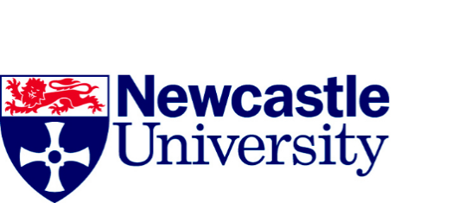

Mapping Contemporary Art in Heritage Experience: Creation, Consumption and Exchange

Research Participant Project Information Sheet – Mapping strand

Introduction
This research project, funded by the Arts and Humanities Research Council (AHRC), aims to critically examine the creation and reception of contemporary visual artworks commissioned for heritage sites. It runs from January 2017 to December 2019 and is led by Newcastle University working in association with Leeds University and partners from the arts and heritage sectors. For more information about our research project please visit http://research.ncl.ac.uk/mcahe/
The project has three main objectives:.
- To map the trajectory of contemporary visual art in heritage sites in the UK.
- To understand how artists engage with the heritage context in the creation of contemporary art for heritage properties.
- To analyse how contemporary artworks commissioned for these contexts are received and consumed by heritage property visitors.
A key objective of our project is to build a picture of the current landscape of contemporary art in heritage activity and to understand what the key issues or barriers are for commissioners, arts organisations, artists and audiences engaged in or wishing to develop this area of practice. Your willingness to share your experience of working in this field through this interview is therefore a vital part of our information gathering.
As an interviewee and participant in our research we ask you to sign a ‘Consent Form’. This is a form you sign to say that you understand why the study is being done, that you understand what you are expected to do and what the researchers will do with the information they will collect.
Who is organising and funding the study?
The study is organised by the University of Newcastle, with the University of Leeds and national and regional partners from the arts and heritage sectors. It is funded by the Arts and Humanities Research Council. All research in Newcastle University is looked at by an independent group of people, a Research Ethics Committee, to protect your safety, rights, well-being and dignity. This study has been reviewed and given favourable opinion by the Newcastle University Faculty of Humanities and Social Sciences.

What if I have a problem or complaint?
If you are harmed by taking part in this study, there are no special compensation arrangements. If you are harmed due to someone’s negligence, then you may have grounds for a legal action, but you may have to pay for your legal costs. If you are unhappy or dissatisfied about any aspect of your participation, we would ask you to tell us about this in the first instance, so that we can try to resolve any concerns and find a solution. If you have any cause to complain about how you have been approached or treated during this study, please contact the Principle Investigator, Andrew Burton: andrew.burton@ncl.ac.uk

