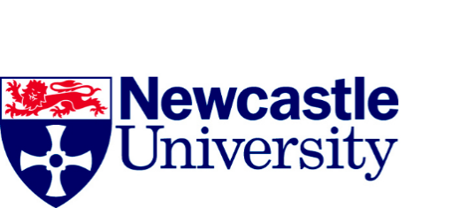

Mapping Contemporary Art in Heritage Environment: Creation, Consumption and Exchange

Artist’s Consent Form

Name of Researcher:_______________________________ Please initial all boxes

I confirm that I have read and understand the information sheet for the above study and have had the opportunity to ask questions.
I understand and give permission for data collected from me during the study to be used in the ways outlined in the information sheet.
I understand and give permission for group meetings or interviews that I am asked to take part in, to be audio recorded.
I agree to take part in the above study.

Name of Participant: Date:
Signature

1 x copy to participant; 1 x copy for office use

