  - D3.2.4 Modelling Tool Refinement

Newcastle University ǀ 16/12/2020
Revision 1.0

Chris Mullen, Neal Wade, Faye Harland

Document control
Stage | Name | Date | Note
Prepared | CM | 14/12/2020
Checked | NW | 16/12/2020
Feedback incorporated

Contents
Introduction 3
Scenario set up 3
Scenario 0: Pre-SLES system baseline 3
Scenario 1: PV added to the system 4
Scenario 2: FOM battery added to system (optimise on monetary cost) 6
Scenario 3: Battery added to system, optimise for emissions 7
Cost Comparisons 9
Limitations of this work 10

Introduction
This report describes modelling work achieved in calliope for some of the SLES assets. Specifically it considers a large penetration of PV at the demand side of the network and a grid connected battery.

Scenario set up
There are several scenarios explored in this modelling work and these are detailed below.
Scenario 0 is the baseline scenario consists of domestic demand (at ‘region 2’) connected to the grid (at ‘region 1’) via a distribution cable with efficiency of 0.85 (non-linearities are not considered). This represents a pre-SLES system baseline (as described in report D4.3.2).
Scenario 1 adds high penetration of solar PV at the demand location (‘region 2’) and calculates the cost and emissions reductions. At some points the PV generation exceeds the demand and this excess is exported to the grid. In these scenarios we don’t take account of installation and purchase costs, but these could be added later based on actual project data or estimations from literature. This can be considered as the SLES independent baseline for PV.
Scenario 2 adds a large (15 MWh, 10MW) battery at the grid supply (‘region 1’). Although the battery is installed to meet a contracted service (i.e. frequency response), we assume that for the modelling period the battery has no obligation to its contracted service. This is SLES co-operative mode since the battery is working in conjunction with another asset in order to create value ‘greater than the sum of the parts’. The system is optimised on monetary cost of energy. The financial and CO₂ emissions costs are noted.
Scenario 3 is the same as scenario 2 except that the system is optimised on CO₂ emissions rather than monetary cost. The financial and emissions costs are noted. Again this represents SLES co-operative mode, but with a different objective.
The monetary and CO₂ emissions costs are compared.
Note that it is possible to optimise on both monetary costs and CO₂ emissions costs by specifying the relative importance of each. However, in order to calibrate the relative importance, the costs would need to have the same units. This could be achieved by assigning a financial cost to CO₂ emissions.

Scenario 0: Pre-SLES system baseline
The graph in Figure 1 shows a 5-day period in January with the grid power supplied at the transformer, power demand. This represents the system before any SLES assets are installed. The grid supply is higher than the demand since there are losses in the distribution cables.
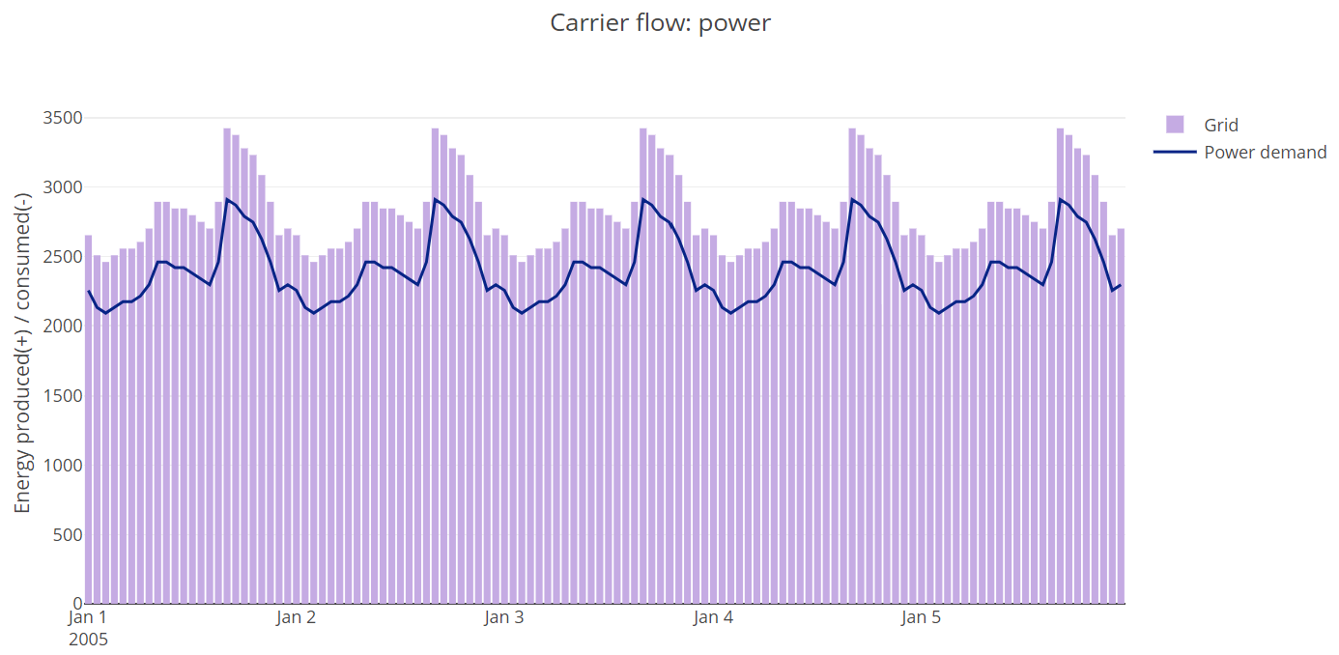
Figure 1 Power profile over 5 days
Energy supplied and distributed is shown in Table 1. The distribution Region 2 represents the energy distributed to the demand region. There is no energy flow from demand to the grid supply at region 1, therefore the energy value for distribution region 1 is zero.
Point of Supply of Distribution | Energy Supplied or C
Grid Supply (kWh) | 339,000
Distribution Region1 (kWh) | 0
Distribution Region2 (kWh) | 288,000
Table 1 Baseline energy Supplied and distributed
The costs in the baseline scenario are shown in Table 2. The costs of transmission are given in the first two columns. Battery and PV are not included in the pre-SLES system baseline, the costs of supply from the grid and the total cost are given in the last two columns.
 | AC distr. (region1) | AC distr. (region2) | Battery | PV | Grid Supply | Total
Emissions (kgCO₂) | 0 | 0 | n/a | n/a | 105,000 | 105,000
Monetary (£) | 576 | 0 | n/a | n/a | 33,900 | 34,500

Table 2 Baseline costs

Scenario 1: PV added to the system
The graph in Figure 2 shows a 5-day period in January with the grid power supplied at the transformer, power demand and PV power. Some of the PV power is exported to the grid where the PV generation exceeds the demand: this is not shown on the graphs, but is calculated later.
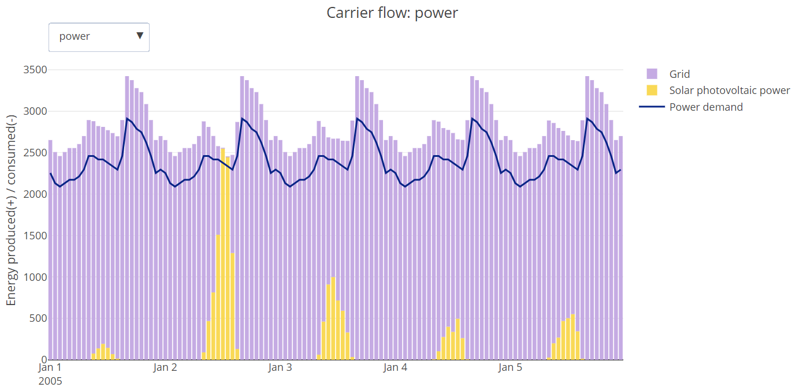
Figure 2 Power profile over 5 days
Table 3 shows the energy supplied and distributed in the system. The grid supplies 318,000 kWh of energy to meet 271,000 kWh demand. The total PV energy exported from Region 2 is 1,050 kWh. lThe energy consumed at Distribution Region 1 (890 kWh) represents the exported PV at the grid side, after distribution losses from Region 2 to Region 1. This renewable energy exported out of the system represents renewable energy that is not consumed locally. The demand (288,000 kWh from previous scenario) is met by the sum of the PV generation at region 2 and the distribution at region 2.
Grid Supply (kWh) | 318,0006
PV export from Region 2 |(kWh) | 1,050
Distribution Region1 (kWh) | 890
Distribution Region2 (kWh) | 270,000
PV Region 2 (kWh) | 18,300
Table 3 Energy Supplied and distributed
Table 4 shows the scenario monetary costs and carbon emissions impact. The monetary costs and carbon emissions are significantly reduced compared to the pre-SLES baseline case: the carbon reduction is 7.43 tonnes-CO₂ and the monetary reduction is £2,153

 | AC distr. (region1) | AC distr. (region2) | Battery | PV | Grid Supply | Total
Emissions (kgCO₂) | 0.0 | 0.00 | n/a | 0.0 | 97,900 | 97,900
Monetary (£) | 541 | 2 | n/a | 0.0 | 31,800 | 32,300
Table 4 Scenario 1 costs

Scenario 2: FOM battery added to system (optimise on monetary cost)
The battery stores the excess PV generation to reduce grid import when the PV generation is less than the demand. Since there is a distribution cable between the PV and the battery there are technical losses associated with doing this. Since the optimisation is on monetary cost, the battery only stores energy when the excess PV generation would otherwise supply demands outside the local area. Figure 3 shows the power profile and Figure 4 shows the battery charge and discharge profile and state of charge. Clearly the battery is over-sized for this function alone. However, if the battery were contracted to another service (e.g. frequency response) it could also store and release excess PV generation during out-of-contract periods.
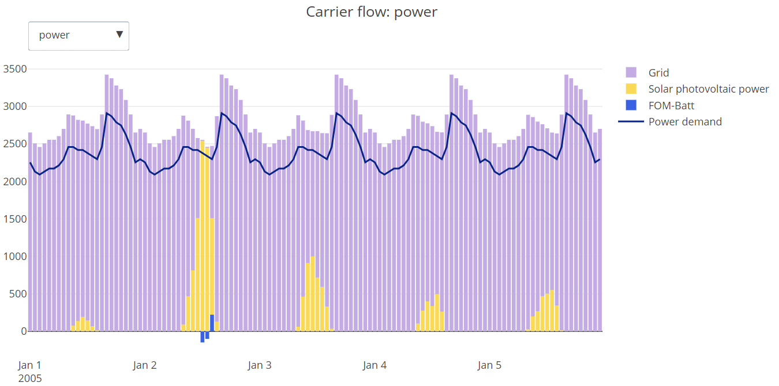
Figure 3 Power profile over 5 days
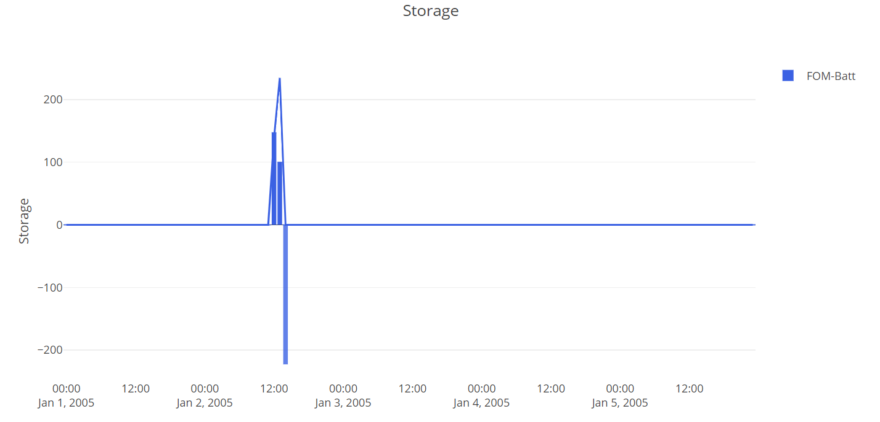
Figure 4 Battery supply/demand (kW) and state of charge (kWh)
Table 5 shows the energy supplied and distributed in the system. The energy at Distribution Region 1 is the excess PV generation after transmission losses, but this is absorbed by the battery. The reason for the difference between this and the energy stored in the battery is that the battery is 0.95 efficient, which equates to 0.9025 (0.95²) round-trip charge/discharge efficiency.
Grid Supply (kWh) | 318,000
Distribution Region1 (kWh) | 246
Distribution Region2 (kWh) | 270,000
PV Region 2 (kWh) | 18,300
Battery (kWh) | 222
Table 5 Energy Supplied and distributed
Table 6 shows the scenario monetary costs and carbon emissions impact. Again, the monetary costs and carbon emissions are significantly reduced compared to the pre-SLES baseline case: the carbon reduction is 7.51 tonnes-CO₂ and the monetary reduction is £2,178.
 | AC trans. (region1) | AC trans. (region2) | Battery | PV | Grid Supply | Total  (£)
Emissions (kgCO₂) | 0.00 | 0.00 | 0.0 | 0.0 | 97,800 | 97,800
Monetary (£) | 540 | 0.5 | 0.0 | 0.0 | 31,800 | 32,300
Table 6 Scenario 2 costs

Scenario 3: Battery added to system, optimise for emissions
This scenario is the same as the previous but the system is optimised on carbon emissions. The power profile is shown in Figure 5 and Figure 6 shows the battery charge/discharge and state of charge. Optimising on CO₂ emissions makes more frequent use of the battery since the low-carbon intensity electricity is stored and discharged every day, according to the profile of the carbon-intensity.
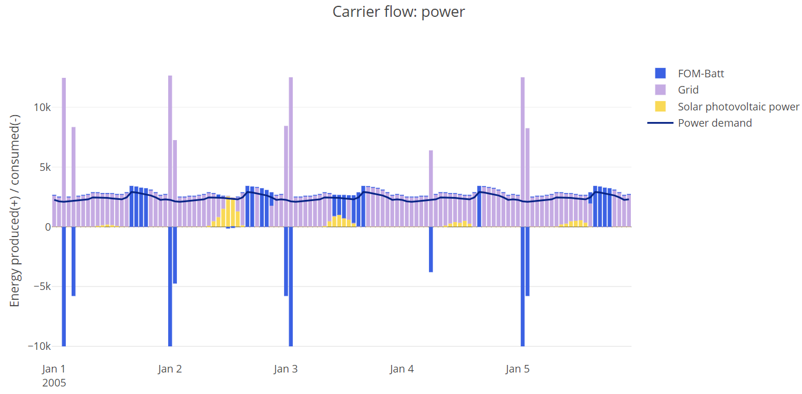
Figure 5 Power profile over 5 days
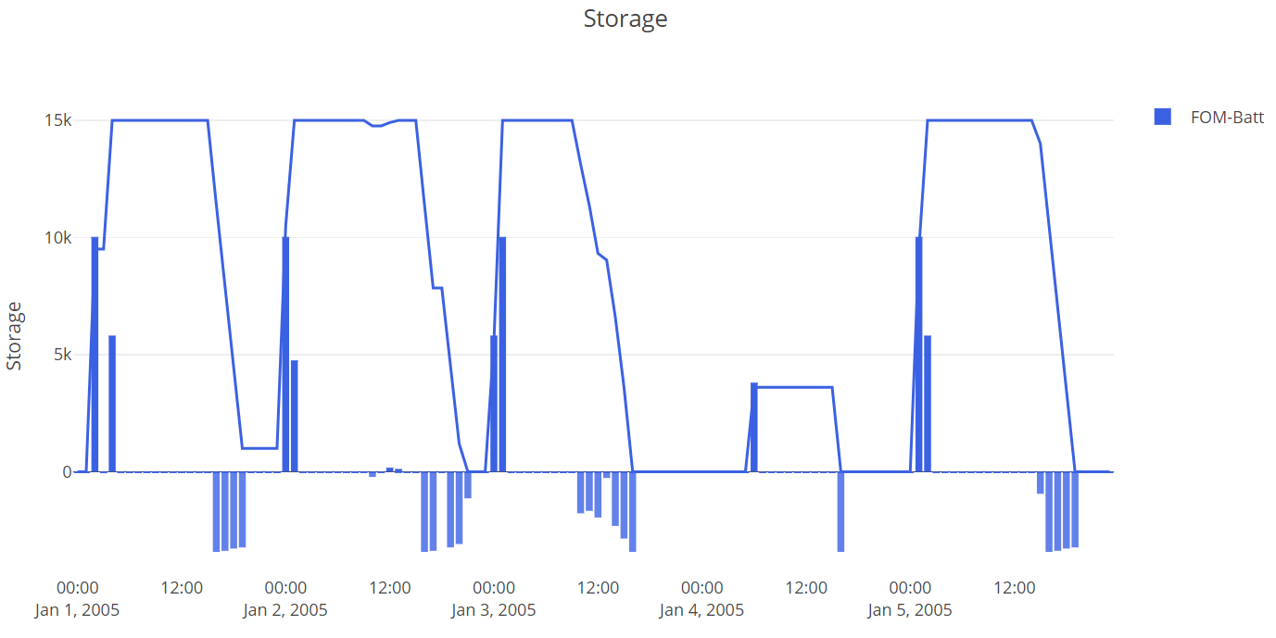
Figure 6 Battery supply/demand (kW) and state of charge (kWh)
Table 7 shows the energy supplied and distributed in the system. The battery stores both the excess PV generation and the low-carbon-intensity electricity.
Grid Supply (kWh) | 323,960
Distribution Region1 (kWh) | 270,093
Distribution Region2 (kWh) | 246
PV Region 2 (kWh) | 18,311
Battery (kWh) | 59,703
Table 7 Energy Supplied and distributed
Table 8 shows the scenario monetary costs and carbon emissions impact. Again, the monetary costs and carbon emissions are significantly reduced compared to the pre-SLES baseline case: the carbon reduction is 13.11 tonnes-CO₂ and the monetary reduction is £1,535.
 | AC trans. (region1) | AC trans. (region2) | Battery | PV | Grid Supply | Total
Emissions (kgCO₂) | 0.00 | 0.00 | 0.0 | 0.0 | 92,220 | 92,220
Monetary (£) | 540 | 0.5 | 0.0 | 0.0 | 32,400 | 32,900
Table 8 Scenario 3 costs

Cost Comparisons
Table 9 and Table 10 give a breakdown of costs relative to the pre-SLES asset case. Scenario 2 and 3 consisted of the same system with different operational goals. The figures here suggest significant differences in monetary or CO₂ reductions, depending on the optimisation.
techs | Distribution Region1 | Distribution Region2 | Grid Supply | Total
Emissions costs (kgCO₂) | 0.00 | 0.00 | -7,506 | -7,506
Monetary costs (£) | -36 | 0.5 | -2,140 | -2,180
Table 9 Scenario 2 costs relative to baseline (-ve indicates Scenario 2 cost is lower)
techs | Distribution Region1 | Distribution Region2 | Grid Supply | Total
Emissions costs (kgCO₂) | 0.00 | 0.00 | -13,100 | -13,100
Monetary costs (£) | -36 | 0.5 | -1,500 | -1,540
Table 10 Scenario 3 costs relative to baseline (-ve indicates Scenario 3 cost is lower)

Limitations of this work
The work presented here does not account for capital costs which are usually distributed over the expected lifetime of the asset, in order to give a levelised cost of energy. These costs can be added to the existing model at a later date.
The optimisation has perfect knowledge of demand and accounts for it. In a real system future demand is not known and must be estimated.
The battery has been sized at the outset to represent typical grid connected storage. If this battery were to be used solely for energy cost reduction of the system as presented it would be sized differently. Whilst it is possible to optimise the battery size, this report models a fixed battery size on the assumption that it is has been sized to meet another income generating service such as frequency response.
The battery is assumed to be 100% available which would not be the case if it were contracted for another service.

