Fitting Software Instructions
Summary of things software can do
- Simulate frequency response of desired circuit with specified parameters.
- Load in experimental txt and DTA data. Data can be time series data at different frequencies, complex impedance or separate real and imaginary impedance data. Knowledge is needed of the data format i.e. What column contains the impedance and frequency data.
- Use a range of different optimisation techniques to find best fit for data for the specified circuit, over a specified frequency range
Instructions
Inputting Circuit
Circuits can be made up of R, C, Q, W, T, O, L, t, o, S, D and G elements although more could be implemented. These elements are defined below.
Circuits should be entered using a combination of [ ] and . to indicate the parallel components of the circuit.
Examples.
R[R.C] would indicate a resistor in series with a resistor that is in parallel with a capacitor
[C.C.C] would indicate 3 capacitors in parallel
R[RW.C] would be standard Randles circuit with a resistor and Warburg element in parallel with a capacitor and a second resistor in series with this
R[RW.C][RW.C] would be two Randles circuits in series with each other

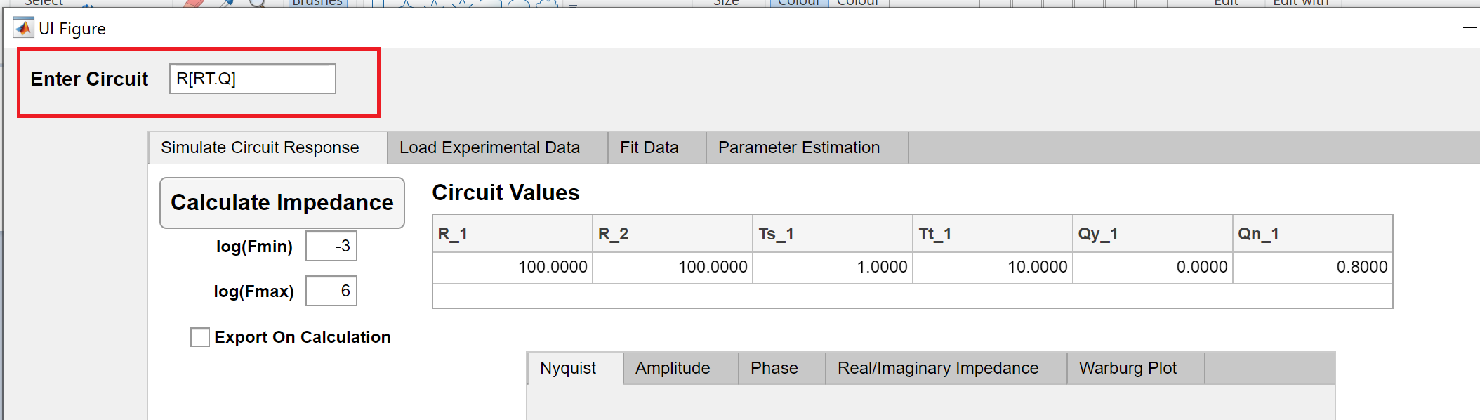
Figure 1. Circuit entered here

Available Circuit Elements
Resistor (R) – Function of 1 Parameter: R
$$Y=\frac{1}{R}$$
$$Z=R$$

Capacitor (C) – Function of 1 Parameter: C
$$Y= C2πfi$$
$$Z= \frac{1}{C2πfi}$$

Inductor (L) – Function of 1 Parameter: L
$$Y= \frac{-i}{2πfL}$$
$$Z= \frac{-i}{2πfL}$$

Constant Phase Element (Q) – Function of 2 Parameters: Q_{y}, Q_{n}
$$Y= Q_{y}({2πfi)}^{Q_{n}}$$
$$Z= \frac{1}{Q_{y}({2πfi)}^{n}}$$

Infinite Warburg (W) – Function of 1 Parameter: W_{s}
$$Y=\frac{\sqrt{2πfi}}{W_{s}}$$
$$Z=\frac{W_{s}}{\sqrt{2πfi}}$$

Planar Finite Space Warburg (T) – Function of 2 Parameters: T_{s}, T_{t}
$$Y=\frac{\sqrt{2πfi}}{T_{s}\coth{(\sqrt{2πfi} T_{t})}}$$
$$Z=\frac{T_{s}\coth{(\sqrt{2πfi} T_{t})}}{\sqrt{2πfi}}$$
Planar Finite Length Warburg (O) – Function of 2 Parameters: O_{s}, O_{t}
$$Y=\frac{\sqrt{2πfi}}{O_{s}\tanh{(\sqrt{2πfi} O_{t})}}$$
$$Z=\frac{O_{s}\tanh{(\sqrt{2πfi} O_{t})}}{\sqrt{2πfi}}$$

Generalised Planar Finite Space Warburg (t) – Function of 3 Parameters: t_{s}, t_{t}, t_{p}
$$Y=\frac{{\left(\sqrt{2πfi}t_{t} \right)}^{t_{p}}}{t_{s}t_{t}\coth{{(\sqrt{2πfi} t_{t})}^{t_{p}}}}$$
$$Z=\frac{t_{s}t_{t}\coth{{(\sqrt{2πfi} t_{t})}^{t_{p}}}}{{\left(\sqrt{2πfi}t_{t} \right)}^{t_{p}}}$$

Generalised Planar Finite Length Warburg (o) – Function of 3 Parameters: o_{s}, o_{t}, o_{p}
$$Y=\frac{{\left(\sqrt{2πfi}t_{t} \right)}^{o_{p}}}{o_{s}o_{t}\tanh{{(\sqrt{2πfi} o_{t})}^{o_{p}}}}$$
$$Z=\frac{o_{s}o_{t}\tanh{{(\sqrt{2πfi} o_{t})}^{o_{p}}}}{{\left(\sqrt{2πfi}o_{t} \right)}^{o_{p}}}$$

Internal Spherical Diffusion (S) – Function of 2 Parameters: S_{s}, S_{t}
$$Y=\frac{\sqrt{2πfi}\coth{(\sqrt{2πfi}}S_{t})-\frac{1}{S_{t}}}{S_{s}}$$
$$Z=\frac{S_{s}}{\sqrt{2πfi}\coth{(\sqrt{2πfi}}S_{t})-\frac{1}{S_{t}}}$$

External Spherical Diffusion (D) – Function of 2 Parameters: D_{s}, D_{t}
$$Y=\frac{\sqrt{2πfi}D_{t}+1}{D_{s}D_{t}}$$
$$Z=\frac{D_{s}D_{t}}{\sqrt{2πfi}D_{t}+1}$$

Gerisher Element (G) – Function of 2 Parameters: G_{y}, G_{k}
$$Y=G_{y}\sqrt{G_{k}+2πfi}$$
$$Z=\frac{1}{G_{y}\sqrt{G_{k}+2πfi}}$$

Simulate Circuit Response

Loading Experimental Data
File Format
Currently .txt and .DTA files can be loaded but if other file types are to be used, this could be changed. Data can be either:
1) Time series potential or current data at different frequencies which will be Fourier transformed to obtain frequency data. In this case, data must contain a column containing time data, frequency data, potential data (either amplitude if it is the applied signal or time series), current data (either amplitude if it is the applied signal or time series). Optionally the data can also include reference potential data as a time series.
2) Frequency and Impedance column data expressed as a complex number.
3) Frequency, real impedance data and imaginary impedance data as columns in the file.
In each case before the frequency and time columns there may be additional columns representing other parameters if more than one data set is present in the file.
In order to load experimental data into software:
- Click select file and find the target file on your computer, a preview of the data if it is possible to read will appear in the bottom right table
- Select file type from the drop down menu depending on the above mentioned cases: time series, complex impedance or separate real and imaginary parts
- Fill in Data Settings table. “Number of Parameters” refers to initial columns in the data to identify multiple experiment conditions If data contains more than one dataset. Other columns should be filled in according to data. Reference data should be set to 0 if not applicable. Relaxation points refers to the number of points at the start of time series data that should be disregarded
- Click Import Data
- Can then click correct area, invert Z”, parameter set (if data contains more than one set) and select which electrode to view if applicable (if reference data was included) to update the loaded data
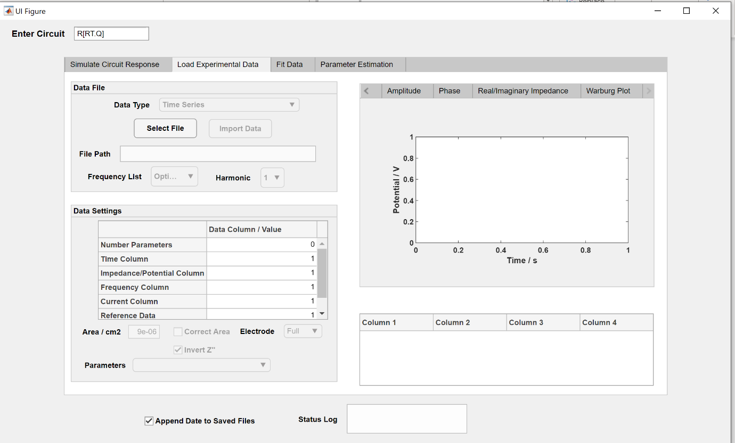
Fig 2. Data Import Screen

Performing Circuit Fitting
Once experimental data is loaded and has been corrected for area/inverted (if applicable), the desired electrode selected, etc., fitting can begin.
Initial guesses for the data fitting can be inputted to the first row of the table on the “Fit Data” tab. The second row of the table sets bounds of:
Lower Bound = 1/Fit Range Multiplier * Initial Value
Upper Bound = Fit Range Multiplier * Initial Value

The frequency range can be set to select range in which to apply fitting procedure. The fit method can be selected from the drop down menu and is either based on a local minimum search (around initial guess), pattern search and genetic algorithm which are intended to find more global best fits for the data. The accuracy of the genetic algorithm can be improved by increasing the value of “Population Size / Iterations” but this will take longer than the other fittings. Once ready, press the fit button to run.
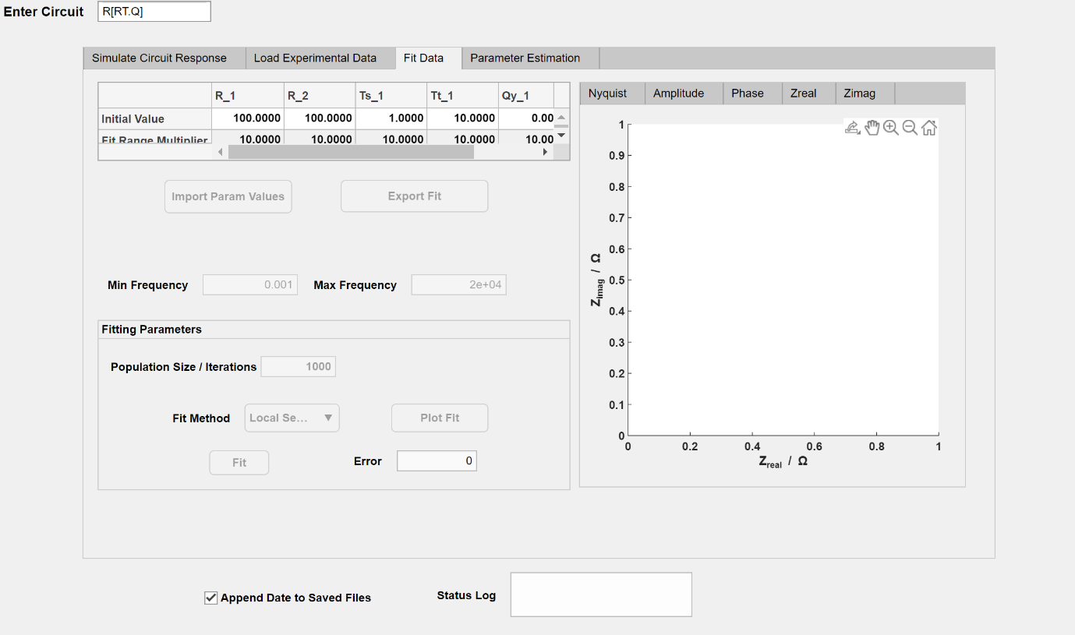
Fig 3. Data fitting screen

Exporting Data
Once data has been fitted and a local/global minima found, the fitted parameters will replace the existing values in the table. These values and the experimental and fitted data can be exported by pressing Export Fit which will open up a save file dialog box. If the “Append Date to Saved Files” is ticked, the date will be added to the filename. If the file already exists in the save location, a number will be appended as well.

Initial Guess for fit Values
Whilst the fitting software can find global best fits if the fit bounds are wide enough, the fitting procedure is facilitated by good initial guesses and smaller uncertainty bounds. Guesses for capacitance values (C or Q_{y}) and the mass transport parameters (Ws, Ts, Os, ts, os, ds) can be approximated using the final tab “Parameter Estimation”. Capacitance values can be estimated from estimating the Resistance of a time constant arc and the frequency at which the arc maximum occurs. Mass transport parameters can be estimated by taking the slope of the Warburg plot in the low frequency (45 degree) region of the data.

R-Resistor
C-Capacitor
T-finite space Warburg (For Planar Electrodes)
L-Inductor
W-Warburg
Q-Constant Phase Element
O-Finite Length Warburg (For Planar Electrodes)
G-Gerischer element
H-Havriliak-Negami element
S-Internal Spherical Diffusion element
P-Same as T but the parameters are more easily converted to diffusion coefficients (For Planar Electrodes)

