THE EFFECT OF TRAFFIC-LIGHT LABELS AND TIME PRESSURE ON ESTIMATING KILOCALORIES AND CARBON FOOTPRINT OF FOOD

APPENDIX 1: Full list of products
Table A1: Full list of products (values per 100g)
ID | Category | Product name | Carbon footprint | Kcal
1 | Vegetables | Carrots Class 1 Pack (1 kg) | 83 | 42
2 |  | Market Value Carrots 1 Pack (1 kg) | 81 | 42
3 |  | Yorkshire Carrots Class 1 Pack (1 kg) | 79 | 42
4 |  | Cucumber Whole (360g) | 133 | 11
5 |  | Yorkshire Cucumber Whole (360g) | 163 | 11
6 |  | Closed Cup Mushrooms 250g | 480 | 16
7 |  | Dorset Closed Cup Mushrooms 250g | 560 | 16
8 |  | Value Closed Cup Mushrooms 250g | 470 | 16
9 | Frozen peas | Frozen Petits Pois 1kg | 125 | 59
10 |  | Frozen Organic Petit Pois 1kg | 225 | 59
11 | Baked beans | Baked Beans in Tomato Sauce 420g | 130 | 87
12 |  | Light Choice Baked Beans in tomato sauce 420g | 130 | 70
13 |  | Value Baked Beans in Tomato Sauce 420g | 140 | 87
14 | Olive oil | Extra Virgin Olive Oil 500 ml | 467 | 900
15 |  | Organic Extra Virgin Olive Oil 500 ml | 360 | 900
16 | Pasta | Whole wheat Spaghetti 500g | 293 | 346
17 |  | Value Spaghetti (500g) | 320 | 351
18 |  | Spaghetti 500g | 320 | 360
19 |  | Organic Spaghetti 500g | 320 | 350
20 |  | Organic Whole wheat spaghetti 500g | 320 | 340
21 | Prepared meals | Braised Beef & Mash 450g | 810 | 101
22 |  | Light Choice Braised Beef and Mash 450g | 990 | 73
23 |  | Chilli con carne and rice 500g | 1070 | 116
24 |  | Light Choices Chilli Con Carne & Rice 500g | 900 | 100
25 |  | Cottage Pie 450g | 1040 | 106
26 |  | Light Choices Cottage Pie 450g | 900 | 82
27 |  | Value Cottage Pie 450g | 750 | 73
28 | Soya milk | Sweetened Soya milk (1 litre) | 80 | 42
29 |  | Unsweetened Soya milk (1 litre) | 70 | 34
30 |  | Value Unsweetened Soya milk (1 litre) | 70 | 34
31 |  | Organic Unsweetened Soya milk (1 litre) | 120 | 34
32 |  | Organic Sweetened Soya milk (1 litre) | 140 | 42
33 | Milk | UHT value skimmed milk (1 litre) | 123 | 50
34 |  | UHT whole milk (1 litre) | 158 | 65
35 |  | UHT skimmed milk (1 litre) | 123 | 50
36 | Eggs | Barn Medium eggs (6-pack) | 413 | 131

ONLINE APPENDIX 1: Full questionnaire
Explanation of Kilocalories [randomise order of information, presented in different pages]
A kilocalorie is a measure of how much energy you get from a certain quantity of food. Calories from carbohydrates, proteins, and fats provide energy that allows the human body to perform all its functions, such as breathe, engage in physical activity (walking, running), and support growth in infants and children. Other nutrients (e.g. vitamins and minerals) and water are essential parts of a healthy diet, but do not provide energy. Eating too many calories leads to weight gain and obesity, which are associated with several diseases (e.g., heart disease, cancer). Nutrition labels generally present information on carbohydrates (which include sugars), fat, and salt, and use traffic-light colours to allow consumers to identify harmful levels of each, as shown below.
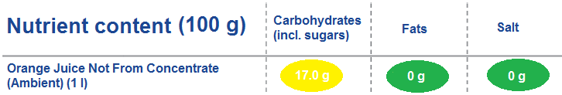
The recommended daily calories intake is 1,800 kilocalories for women and 2,000 kilocalories for men.
Explanation of Carbon Footprint
The carbon footprint of a food is the amount of greenhouse gases emitted to produce and consume the food. It is expressed in tonnes of carbon dioxide equivalents, or “tonnes of CO₂e” for short. The carbon footprint measures the impact of the consumption of a product on global warming by summing all emissions of gases from the production of raw materials, industrial processing, transport, storage, cooking, and consumption. For instance, eating an egg emits CO₂ to: make and deliver feed for the hens; heat the shed to maintain the hens healthy; transport the eggs by van; store eggs in chilled rooms; produce the packaging in which eggs are sold; and use energy for cooking it. A possible carbon footprint label can present individuals with information of the level of emissions the product requires at each stage of the food chain, as shown below.
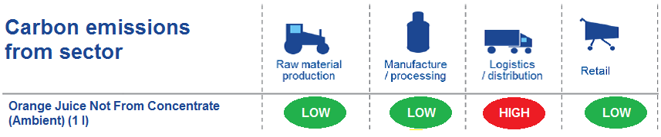
There are currently no agreed guidelines on the optimal daily amount of carbon footprint.
STEP 1: Rate the Environmental Impact of Food (randomise order of step 1 and 2; randomise the order of each box)
According to your knowledge and opinion, how damaging would you say each of these foods are towards the environment? Remember that a higher carbon footprint indicates a higher damage.
Note that all products are currently sold in a large UK supermarket chain using their own brand.

The carbon footprint of this sample is below 1040 gCO2e per 100g of product. Some examples:
(the table should be visible at all time during the task)
NOTE: this table must be visible throughout the task
Product name | CO₂ footprint (100g)
Red Kidney Beans 500g | 300
Cannellini Beans 500g | 300
Wafer Thin Roast Chicken 205g | 720
Plum Peeled Tomatoes (tin) 400g | 120
Beef Lasagne 400g | 1000
Curly Fries 400g | 260
Wafer Thin Roast Chicken 450g | 680
Corn Flakes 750g pack | 317
Fresh Single Cream 150 ml | 336
Still Water 2 litres bottle | 20
______________________________________________________________________________

Product name | Good for the environment | Bad for the environment | Unsure | CO₂ footprint (100g)
Carrots Class 1 Pack (1 kg) |  |  |  | ________________
Market Value Carrots 1 Pack (1 kg) |  |  |  | ________________
Yorkshire Carrots Class 1 Pack (1 kg) |  |  |  | ________________

Product name | Good for the environment | Bad for the environment | Unsure | CO₂ footprint (100g)
Cucumber Whole (360g) |  |  |  | ________________
Yorkshire Cucumber Whole (360g) |  |  |  | ________________

Product name | Good for the environment | Bad for the environment | Unsure | CO₂ footprint (100g)
Closed Cup Mushrooms 250g |  |  |  | ________________
Dorset Closed Cup Mushrooms 250g |  |  |  | ________________
Value Closed Cup Mushrooms 250g |  |  |  | ________________

Product name | Good for the environment | Bad for the environment | Unsure | CO₂ footprint (100g)
Tesco Frozen Petits Pois 1kg |  |  |  | ________________
Tesco Frozen Organic Petit Pois 500g |  |  |  | ________________

Product name | Good for the environment | Bad for the environment | Unsure | CO₂ footprint (100g)
Baked Beans in Tomato Sauce 420g |  |  |  | ________________
Light Choice Baked Beans in tomato sauce 420g |  |  |  | ________________
Value Baked Beans in Tomato Sauce 420g |  |  |  | ________________

Product name | Good for the environment | Bad for the environment | Unsure | CO₂ footprint (100g)
Extra Virgin Olive Oil 500 ml |  |  |  | ________________
Organic Extra Virgin Olive Oil 500 ml |  |  |  | ________________

Product name | Good for the environment | Bad for the environment | Unsure | CO₂ footprint (100g)
Wholewheat Spaghetti 500g |  |  |  | ________________
Value Spaghetti (500g) |  |  |  | ________________
Spaghetti 500g |  |  |  | ________________
Organic Spaghetti 500g |  |  |  | ________________
Organic Wholewheat spaghetti 500g |  |  |  | ________________

Product name | Good for the environment | Bad for the environment | Unsure | CO₂ footprint (100g)
Braised Beef & Mash 450g |  |  |  | ________________
Light Choice Braised Beef and Mash 450g |  |  |  | ________________
Chilli con carne and rice 500g |  |  |  | ________________
Light Choices Chilli Con Carne & Rice 500g |  |  |  | ________________

Product name | Good for the environment | Bad for the environment | Unsure | CO₂ footprint (100g)
Sweetened Soya milk (1 litre) |  |  |  | ________________
Unsweetened Soya milk (1 litre) |  |  |  | ________________
Value Unweetened Soya milk (1 litre) |  |  |  | ________________
Organic Unsweetened Soya milk (1 litre) |  |  |  | ________________
Organic Sweetened Soya milk (1 litre) |  |  |  | ________________

Product name | Good for the environment | Bad for the environment | Unsure | CO₂ footprint (100g)
UHT value skimmed milk (1 litre) |  |  |  | ________________
UHT whole milk (1 litre) |  |  |  | ________________
UHT skimmed milk (1 litre) |  |  |  | ________________

Product name | Good for the environment | Bad for the environment | Unsure | CO₂ footprint (100g)
Barn Medium eggs (6-pack) |  |  |  | ________________
Organic Medium eggs (6-pack) |  |  |  | ________________
Free-Range Medium eggs (6-pack) |  |  |  | ________________
Value Medium eggs (6-pack) |  |  |  | ________________

Product name | Good for the environment | Bad for the environment | Unsure | CO₂ footprint (100g)
Cola 2 l bottle |  |  |  | ________________
Diet Cola 2 l bottle |  |  |  | ________________

Product name | Good for the environment | Bad for the environment | Unsure | CO₂ footprint (100g)
English Unsalted Butter |  |  |  | ________________
English Salted Butter |  |  |  | ________________

Product name | Good for the environment | Bad for the environment | Unsure | CO₂ footprint (100g)
Cottage Pie 450g |  |  |  | ________________
Light Choices Cottage Pie 450g |  |  |  | ________________
Value Cottage Pie 450g |  |  |  | ________________

STEP 2: Rate the Healthiness of foods (randomise order of step 1 and 2)
According to your knowledge and opinion, how damaging would you say each of these foods are towards health? Remember that more calories indicate a higher damage to health.
Note that all products are currently sold in a large UK supermarket chain using their own brand.

The calories content of this sample is below 1000 kcal per 100g of product. Some examples:
(the table should be visible at all time during the task)
NOTE: this table must be visible throughout the task
Product name | kcal (100g)
Red Kidney Beans 500g | 108
Cannellini Beans 500g | 98
Wafer Thin Roast Chicken 205g | 101
Plum Peeled Tomatoes (tin) 400g | 25
Beef Lasagne al forno 400g | 183
Curly Fries 400g | 243
Wafer Thin Roast Chicken 450g | 101
Corn Flakes 750g pack | 384
Fresh Single Cream 150 ml | 194
Still Water 2 litres bottle | 0
________________________________________________________________________

Product name | Healthy | Unhealthy | Unsure | Calories content (100g)
Carrots Class 1 Pack (1 kg) |  |  |  | ________________
Market Value Carrots 1 Pack (1 kg) |  |  |  | ________________
Yorkshire Carrots Class 1 Pack (1 kg) |  |  |  | ________________

Product name | Healthy | Unhealthy | Unsure | Calories content (100g)
Cucumber Whole (360g) |  |  |  | ________________
Yorkshire Cucumber Whole (360g) |  |  |  | ________________

Product name | Healthy | Unhealthy | Unsure | Calories content (100g)
Closed Cup Mushrooms 250g |  |  |  | ________________
Dorset Closed Cup Mushrooms 250g |  |  |  | ________________
Value Closed Cup Mushrooms 250g |  |  |  | ________________

Product name | Healthy | Unhealthy | Unsure | Calories content (100g)
Tesco Frozen Petits Pois 1kg |  |  |  | ________________
Tesco Frozen Organic Petit Pois 500g |  |  |  | ________________

Product name | Healthy | Unhealthy | Unsure | Calories content (100g)
Baked Beans in Tomato Sauce 420g |  |  |  | ________________
Light Choice Baked Beans in tomato sauce 420g |  |  |  | ________________
Value Baked Beans in Tomato Sauce 420g |  |  |  | ________________

Product name | Healthy | Unhealthy | Unsure | Calories content (100g)
Extra Virgin Olive Oil 500 ml |  |  |  | ________________
Organic Extra Virgin Olive Oil 500 ml |  |  |  | ________________

Product name | Healthy | Unhealthy | Unsure | Calories content (100g)
Wholewheat Spaghetti 500g |  |  |  | ________________
Value Spaghetti (500g) |  |  |  | ________________
Spaghetti 500g |  |  |  | ________________
Organic Spaghetti 500g |  |  |  | ________________
Organic Wholewheat spaghetti 500g |  |  |  | ________________

Product name | Healthy | Unhealthy | Unsure | Calories content (100g)
Braised Beef & Mash 450g |  |  |  | ________________
Light Choice Braised Beef and Mash 450g |  |  |  | ________________
Chilli con carne and rice 500g |  |  |  | ________________
Light Choices Chilli Con Carne & Rice 500g |  |  |  | ________________

Product name | Healthy | Unhealthy | Unsure | Calories content (100g)
Sweetened Soya milk (1 litre) |  |  |  | ________________
Unsweetened Soya milk (1 litre) |  |  |  | ________________
Value Unweetened Soya milk (1 litre) |  |  |  | ________________
Organic Unsweetened Soya milk (1 litre) |  |  |  | ________________
Organic Sweetened Soya milk (1 litre) |  |  |  | ________________

Product name | Healthy | Unhealthy | Unsure | Calories content (100g)
UHT value skimmed milk (1 litre) |  |  |  | ________________
UHT whole milk (1 litre) |  |  |  | ________________
UHT skimmed milk (1 litre) |  |  |  | ________________

Product name | Healthy | Unhealthy | Unsure | Calories content (100g)
Barn Medium eggs (6-pack) |  |  |  | ________________
Organic Medium eggs (6-pack) |  |  |  | ________________
Free-Range Medium eggs (6-pack) |  |  |  | ________________
Value Medium eggs (6-pack) |  |  |  | ________________

Product name | Healthy | Unhealthy | Unsure | Calories content (100g)
Cola 2 l bottle |  |  |  | ________________
Diet Cola 2 l bottle |  |  |  | ________________

Product name | Healthy | Unhealthy | Unsure | Calories content (100g)
English Unsalted Butter |  |  |  | ________________
English Salted Butter |  |  |  | ________________

Product name | Healthy | Unhealthy | Unsure | Calories content (100g)
Cottage Pie 450g |  |  |  | ________________
Light Choices Cottage Pie 450g |  |  |  | ________________
Value Cottage Pie 450g |  |  |  | ________________

STEP 3: Final Questions
Intertemporal discounting (randomise order) (2 questions)
- Imagine that you receive a voucher for a free dinner at a steakhouse restaurant you like (worth £35), valid from today. Imagine also you were asked by the restaurant to wait before using this voucher, in exchange for an additional payment; how much money (in addition to the £35) would you be willing to ask as compensation to delay cashing in the voucher?
Waiting for 1 week | Waiting for 2 weeks | Waiting for 4 weeks
£ _______________ | £ _______________ | £ _______________

- Imagine that you receive a voucher for an own-grown-food vegetarian restaurant you like (worth £35), valid today. Imagine also you were asked by the restaurant to wait before using this voucher, in exchange for an additional payment; how much money (in addition to the £35) would you be willing to ask as compensation to delay cashing in the voucher?
Waiting for 1 week | Waiting for 2 weeks | Waiting for 4 weeks
£ _______________ | £ _______________ | £ _______________

Knowledge (randomise order of questions, and options within question) (4 questions)
Which one of the following has the most calories per 100 grams? (tick one)
Sugar | Starchy foods | Fibre roughage | Fat | Not sure

Which do you think is higher in calories? (tick one)
250 g of unsalted butter | 250 g of regular margarine | Both the same | Not sure

Which one of the following has the highest carbon footprint per standard mug (250 ml)? (tick one)
A black tea | A white coffee | A cappuccino | A latte | Not sure

Which do you think is higher in carbon footprint? (tick one)
2 litres of Cola in 1 plastic bottle | 2 litres of Cola in six 330-ml cans | Both the same | Not sure

Attitudes (randomise order) (1 = very negative, 5 = very positive)
- How do you feel about actions and behaviours that protect the environment?
- How do you feel about actions and behaviours that protect one’s health?

Frequency of purchase
How often have you done any of these during the last 4 weeks? (randomise order)
 | Never | 1-3 times  per month | 1-2 times  per week | 3-6 times  per week | More often than 6 times per week
Purchased food with a health label (e.g., low fat; low salt) to keep healthy.
Purchased food with an environmentally-friendly label to protect the environment.

Self-identity (1 = totally disagree; 5 = totally agree) (randomise order)
Please answer your level of agreement to each statement, which refer to the adjective on top of it.
- Being environmentally-friendly is an important part of who I am.
- Being healthy is an important part of who I am.

ONLINE APPENDIX 2: Labels used in the “labelling” condition
Carbon label
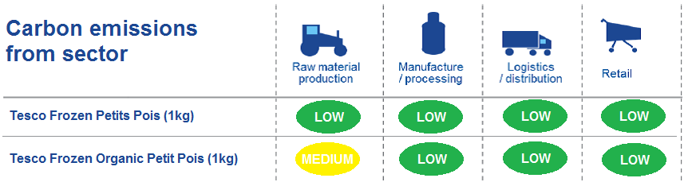
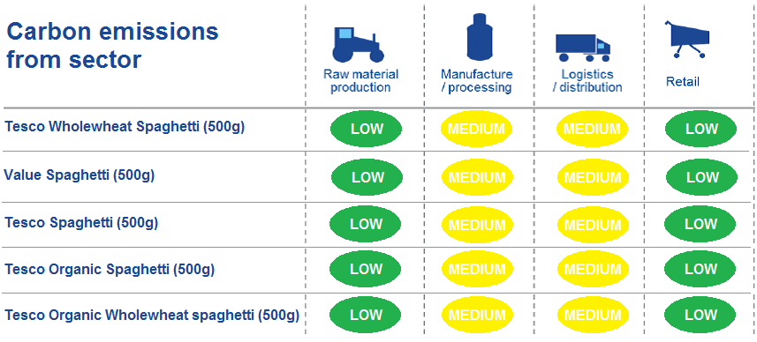
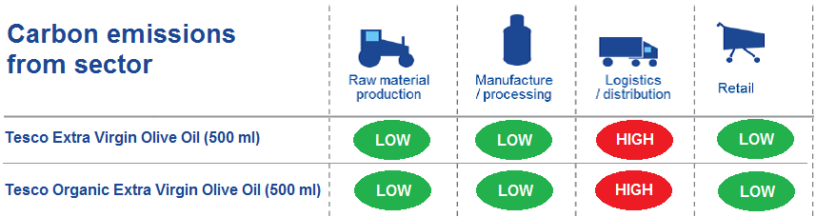
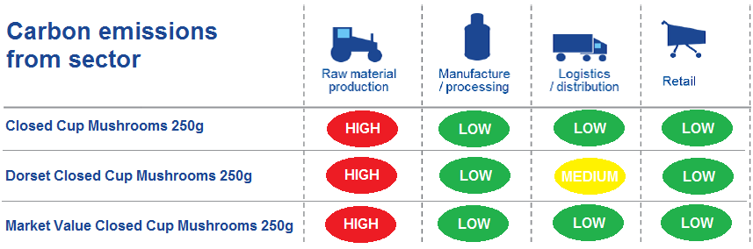
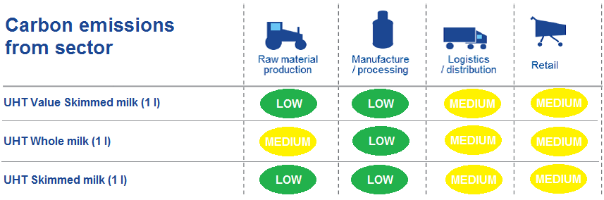
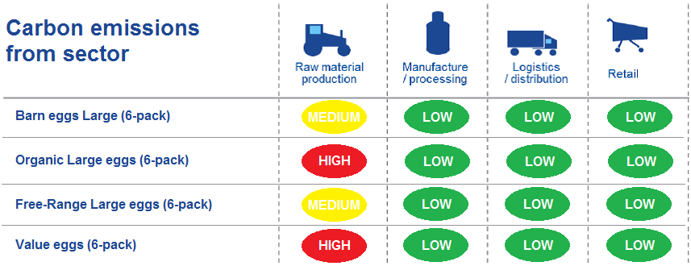
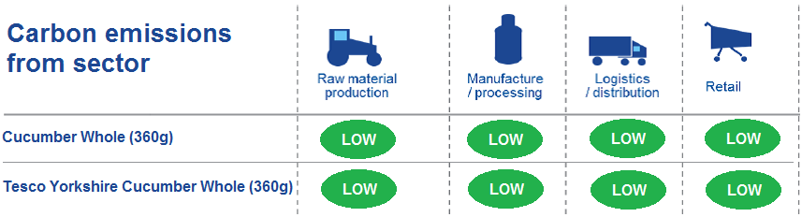
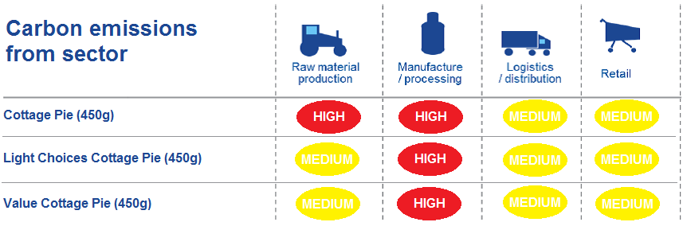
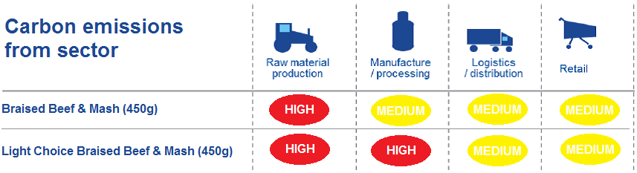
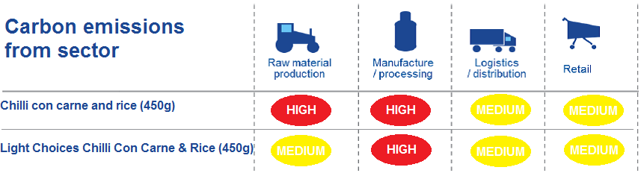
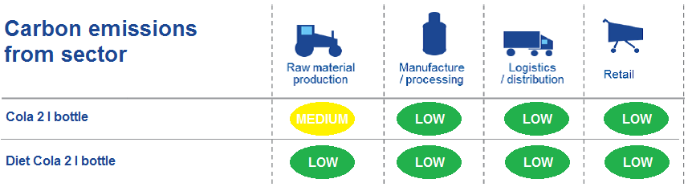
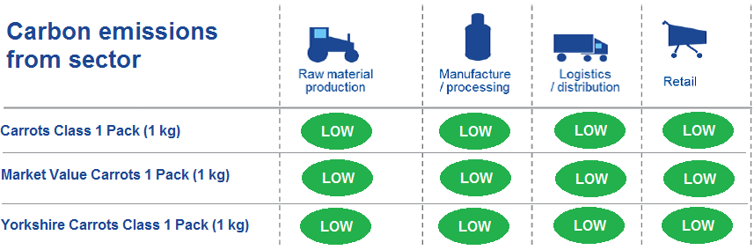
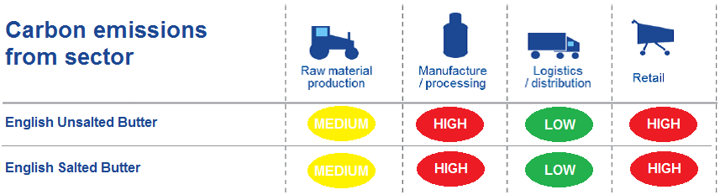
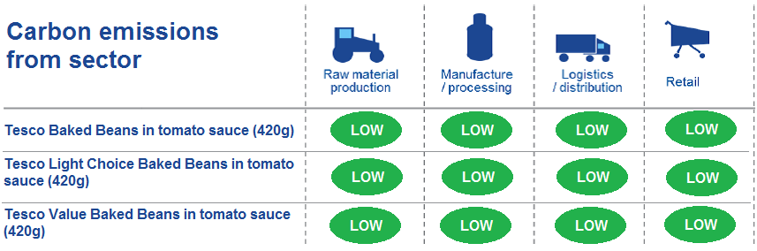
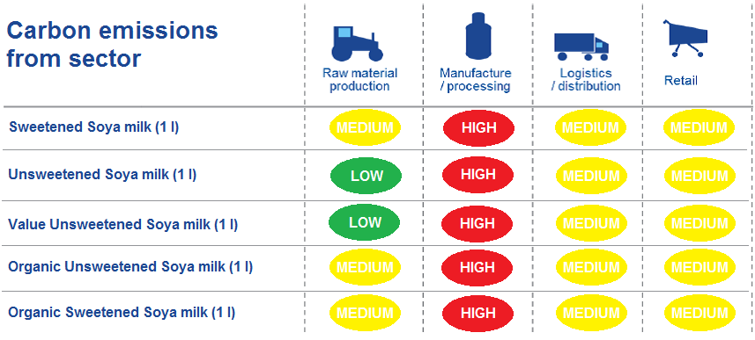

Nutrition label
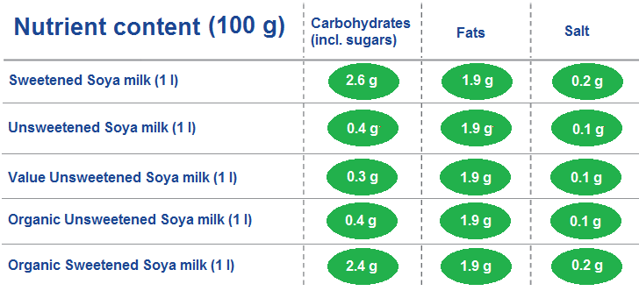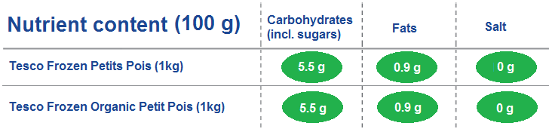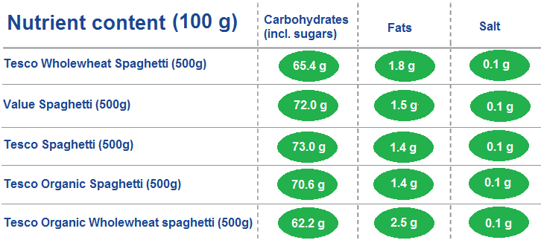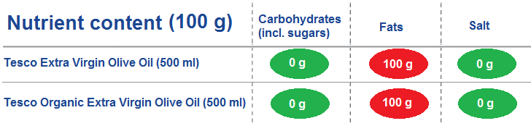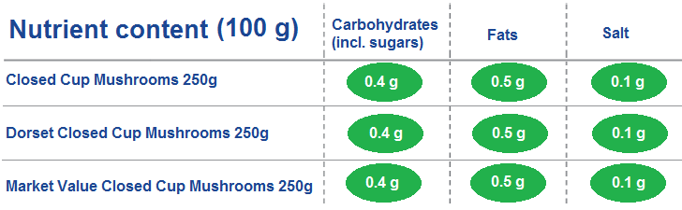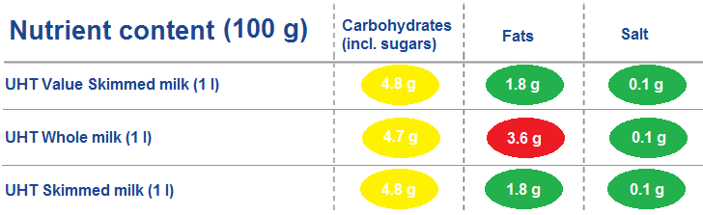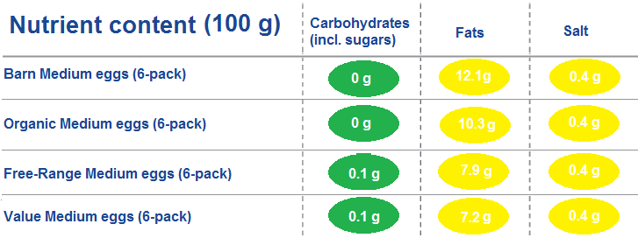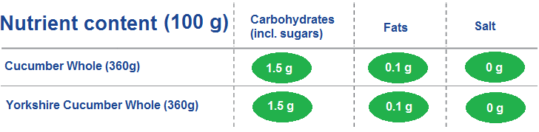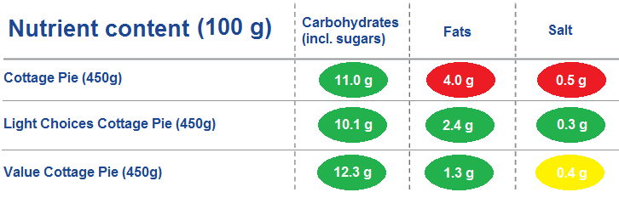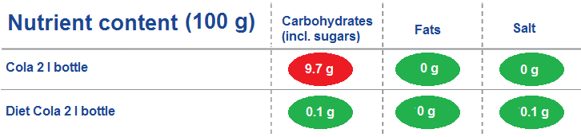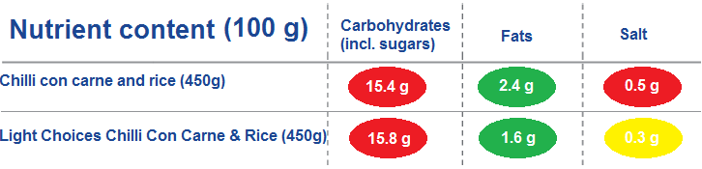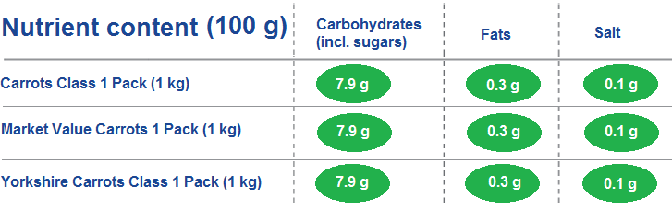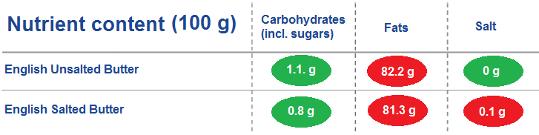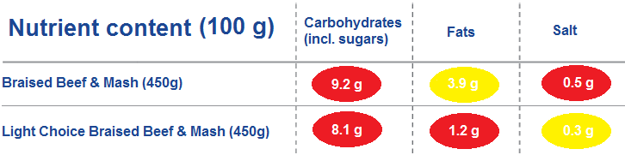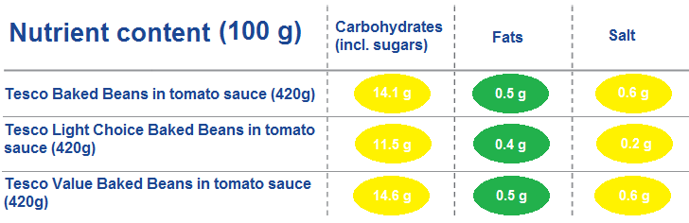

ONLINE APPENDIX 3: Mean and the 95% confidence interval of a metric for each product
a) Carbon footprint
 | Control |  |  | Time pressure |  |  | Labelling |  |  |  |  | Labelling + Time pressure
Product name | Mean | 95% conf. int. |  | Mean | 95% conf. int. |  | Mean |  | 95% conf. int. |  |  | Mean |  | 95% conf. int.
Carrots Class 1 Pack (1 kg) | 4.65 | 4.54 | 4.54 | 4.62 | 4.50 | 4.50 | 4.22 | 4.10 |  | 4.10 | 4.18 |  | 4.04 |  | 4.04
Market Value Carrots 1 Pack (1 kg) | 4.68 | 4.56 | 4.56 | 4.65 | 4.52 | 4.52 | 4.24 | 4.12 |  | 4.12 | 4.17 |  | 4.03 |  | 4.03
Yorkshire Carrots Class 1 Pack (1 kg) | 4.62 | 4.50 | 4.50 | 4.55 | 4.43 | 4.43 | 4.21 | 4.09 |  | 4.09 | 4.17 |  | 4.03 |  | 4.03
Cucumber Whole (360g) | 4.39 | 4.26 | 4.26 | 4.38 | 4.25 | 4.25 | 3.99 | 3.86 |  | 3.86 | 4.02 |  | 3.88 |  | 3.88
Yorkshire Cucumber Whole (360g) | 4.33 | 4.20 | 4.20 | 4.30 | 4.16 | 4.16 | 3.98 | 3.85 |  | 3.85 | 4.02 |  | 3.88 |  | 3.88
Closed Cup Mushrooms 250g | 4.56 | 4.43 | 4.43 | 4.62 | 4.50 | 4.50 | 5.09 | 4.97 |  | 4.97 | 5.05 |  | 4.93 |  | 4.93
Dorset Closed Cup Mushrooms 250g | 4.54 | 4.42 | 4.42 | 4.60 | 4.49 | 4.49 | 5.18 | 5.07 |  | 5.07 | 5.10 |  | 4.98 |  | 4.98
Value Closed Cup Mushrooms 250g | 4.65 | 4.53 | 4.53 | 4.66 | 4.54 | 4.54 | 5.10 | 4.98 |  | 4.98 | 5.07 |  | 4.95 |  | 4.95
Frozen Petits Pois 1kg | 5.10 | 4.98 | 4.98 | 5.03 | 4.92 | 4.92 | 4.62 | 4.50 |  | 4.50 | 4.60 |  | 4.46 |  | 4.46
Frozen Organic Petit Pois 1kg | 5.05 | 4.93 | 4.93 | 4.99 | 4.87 | 4.87 | 4.74 | 4.62 |  | 4.62 | 4.69 |  | 4.56 |  | 4.56
Baked Beans in Tomato Sauce 420g | 5.53 | 5.43 | 5.43 | 5.51 | 5.42 | 5.42 | 4.90 | 4.79 |  | 4.79 | 4.97 |  | 4.84 |  | 4.84
Light Choice Baked Beans in tomato sauce 420g | 5.52 | 5.42 | 5.42 | 5.50 | 5.40 | 5.40 | 4.90 | 4.79 |  | 4.79 | 4.96 |  | 4.83 |  | 4.83
Value Baked Beans in Tomato Sauce 420g | 5.53 | 5.44 | 5.44 | 5.55 | 5.46 | 5.46 | 4.94 | 4.83 |  | 4.83 | 4.96 |  | 4.83 |  | 4.83
Extra Virgin Olive Oil 500 ml | 5.38 | 5.25 | 5.25 | 5.40 | 5.28 | 5.28 | 5.39 | 5.28 |  | 5.28 | 5.32 |  | 5.19 |  | 5.19
Organic Extra Virgin Olive Oil 500 ml | 5.32 | 5.18 | 5.18 | 5.37 | 5.25 | 5.25 | 5.39 | 5.28 |  | 5.28 | 5.32 |  | 5.19 |  | 5.19
Whole wheat Spaghetti 500g | 5.39 | 5.28 | 5.28 | 5.36 | 5.25 | 5.25 | 5.32 | 5.22 |  | 5.22 | 5.29 |  | 5.17 |  | 5.17
Value Spaghetti (500g) | 5.45 | 5.33 | 5.33 | 5.46 | 5.35 | 5.35 | 5.34 | 5.24 |  | 5.24 | 5.34 |  | 5.22 |  | 5.22
Spaghetti 500g | 5.44 | 5.33 | 5.33 | 5.42 | 5.32 | 5.32 | 5.34 | 5.23 |  | 5.23 | 5.32 |  | 5.20 |  | 5.20
Organic Spaghetti 500g | 5.33 | 5.21 | 5.21 | 5.34 | 5.23 | 5.23 | 5.32 | 5.21 |  | 5.21 | 5.28 |  | 5.16 |  | 5.16
Organic Whole wheat spaghetti 500g | 5.30 | 5.17 | 5.17 | 5.30 | 5.18 | 5.18 | 5.29 | 5.18 |  | 5.18 | 5.27 |  | 5.15 |  | 5.15
Braised Beef & Mash 450g | 6.19 | 6.08 | 6.08 | 6.08 | 5.97 | 5.97 | 6.28 | 6.17 |  | 6.17 | 6.09 |  | 5.96 |  | 5.96
Light Choice Braised Beef and Mash 450g | 6.13 | 6.02 | 6.02 | 6.03 | 5.92 | 5.92 | 6.23 | 6.12 |  | 6.12 | 6.05 |  | 5.92 |  | 5.92
Chilli con carne and rice 500g | 6.18 | 6.07 | 6.07 | 6.09 | 5.98 | 5.98 | 6.24 | 6.14 |  | 6.14 | 6.06 |  | 5.93 |  | 5.93
Light Choices Chilli Con Carne & Rice 500g | 6.14 | 6.03 | 6.03 | 6.07 | 5.96 | 5.96 | 6.28 | 6.18 |  | 6.18 | 6.09 |  | 5.97 |  | 5.97
Sweetened Soya milk (1 litre) | 5.36 | 5.24 | 5.24 | 5.34 | 5.22 | 5.22 | 5.72 | 5.60 |  | 5.60 | 5.60 |  | 5.47 |  | 5.47
Unsweetened Soya milk (1 litre) | 5.23 | 5.10 | 5.10 | 5.23 | 5.11 | 5.11 | 5.61 | 5.49 |  | 5.49 | 5.51 |  | 5.38 |  | 5.38
Value Unsweetened Soya milk (1 litre) | 5.30 | 5.17 | 5.17 | 5.27 | 5.15 | 5.15 | 5.61 | 5.50 |  | 5.50 | 5.52 |  | 5.39 |  | 5.39
Organic Unsweetened Soya milk (1 litre) | 5.22 | 5.10 | 5.10 | 5.21 | 5.10 | 5.10 | 5.69 | 5.57 |  | 5.57 | 5.55 |  | 5.42 |  | 5.42
Organic Sweetened Soya milk (1 litre) | 5.31 | 5.19 | 5.19 | 5.30 | 5.18 | 5.18 | 5.71 | 5.60 |  | 5.60 | 5.58 |  | 5.45 |  | 5.45
UHT value skimmed milk (1 litre) | 5.34 | 5.22 | 5.22 | 5.31 | 5.19 | 5.19 | 5.09 | 4.97 |  | 4.97 | 5.12 |  | 4.99 |  | 4.99
UHT whole milk (1 litre) | 5.40 | 5.28 | 5.28 | 5.30 | 5.17 | 5.17 | 5.20 | 5.08 |  | 5.08 | 5.20 |  | 5.07 |  | 5.07
UHT skimmed milk (1 litre) | 5.32 | 5.20 | 5.20 | 5.29 | 5.17 | 5.17 | 5.09 | 4.97 |  | 4.97 | 5.11 |  | 4.98 |  | 4.98
Barn Medium eggs (6-pack) | 5.33 | 5.21 | 5.21 | 5.23 | 5.12 | 5.12 | 5.19 | 5.08 |  | 5.08 | 5.06 |  | 4.93 |  | 4.93
Organic Medium eggs (6-pack) | 5.22 | 5.11 | 5.11 | 5.11 | 5.00 | 5.00 | 5.30 | 5.18 |  | 5.18 | 5.15 |  | 5.01 |  | 5.01
Free-Range Medium eggs (6-pack) | 5.15 | 5.03 | 5.03 | 5.05 | 4.95 | 4.95 | 5.15 | 5.04 |  | 5.04 | 4.98 |  | 4.84 |  | 4.84
Value Medium eggs (6-pack) | 5.39 | 5.27 | 5.27 | 5.31 | 5.20 | 5.20 | 5.35 | 5.24 |  | 5.24 | 5.24 |  | 5.11 |  | 5.11
Cola 2 l bottle | 5.71 | 5.59 | 5.59 | 5.81 | 5.70 | 5.70 | 4.97 | 4.86 |  | 4.86 | 5.16 |  | 5.03 |  | 5.03
Diet Cola 2 l bottle | 5.65 | 5.52 | 5.52 | 5.79 | 5.69 | 5.69 | 4.77 | 4.65 |  | 4.65 | 4.99 |  | 4.84 |  | 4.84
English Unsalted Butter | 5.43 | 5.32 | 5.32 | 5.34 | 5.22 | 5.22 | 5.78 | 5.68 |  | 5.68 | 5.72 |  | 5.60 |  | 5.60
English Salted Butter | 5.49 | 5.38 | 5.38 | 5.37 | 5.26 | 5.26 | 5.80 | 5.71 |  | 5.71 | 5.74 |  | 5.62 |  | 5.62
Cottage Pie 450g | 6.08 | 5.96 | 5.96 | 5.98 | 5.87 | 5.87 | 6.26 | 6.15 |  | 6.15 | 6.14 |  | 6.03 |  | 6.03
Light Choices Cottage Pie 450g | 6.03 | 5.91 | 5.91 | 5.96 | 5.85 | 5.85 | 6.19 | 6.09 |  | 6.09 | 6.01 |  | 5.90 |  | 5.90
Value Cottage Pie 450g | 6.08 | 5.95 | 5.95 | 6.00 | 5.89 | 5.89 | 6.19 | 6.09 |  | 6.09 | 6.01 |  | 5.89 |  | 5.89
b) kilocalories
 | Control |  |  | Time pressure |  |  | Labelling |  |  | Labelling + Time pressure
Product name | Mean | 95% conf. int. |  | Mean | 95% conf. int. |  | Mean | 95% conf. int. |  | Mean | 95% conf. int.
Carrots Class 1 Pack (1 kg) | 3.87 | 3.76 | 3.76 | 3.91 | 3.80 | 3.80 | 3.73 | 3.61 | 3.61 | 3.82 | 3.70 | 3.70
Market Value Carrots 1 Pack (1 kg) | 3.89 | 3.77 | 3.77 | 3.93 | 3.82 | 3.82 | 3.73 | 3.62 | 3.62 | 3.83 | 3.71 | 3.71
Yorkshire Carrots Class 1 Pack (1 kg) | 3.88 | 3.76 | 3.76 | 3.93 | 3.82 | 3.82 | 3.73 | 3.62 | 3.62 | 3.82 | 3.70 | 3.70
Cucumber Whole (360g) | 3.16 | 3.04 | 3.04 | 3.27 | 3.15 | 3.15 | 3.01 | 2.90 | 2.90 | 3.18 | 3.05 | 3.05
Yorkshire Cucumber Whole (360g) | 3.16 | 3.04 | 3.04 | 3.29 | 3.17 | 3.17 | 3.01 | 2.90 | 2.90 | 3.22 | 3.09 | 3.09
Closed Cup Mushrooms 250g | 3.71 | 3.60 | 3.60 | 3.77 | 3.65 | 3.65 | 3.53 | 3.42 | 3.42 | 3.67 | 3.55 | 3.55
Dorset Closed Cup Mushrooms 250g | 3.71 | 3.61 | 3.61 | 3.78 | 3.67 | 3.67 | 3.52 | 3.41 | 3.41 | 3.68 | 3.56 | 3.56
Value Closed Cup Mushrooms 250g | 3.72 | 3.62 | 3.62 | 3.79 | 3.68 | 3.68 | 3.52 | 3.41 | 3.41 | 3.68 | 3.56 | 3.56
Frozen Petits Pois 1kg | 4.14 | 4.03 | 4.03 | 4.11 | 4.00 | 4.00 | 4.00 | 3.90 | 3.90 | 4.11 | 4.00 | 4.00
Frozen Organic Petit Pois 1kg | 4.07 | 3.96 | 3.96 | 4.09 | 3.98 | 3.98 | 3.96 | 3.86 | 3.86 | 4.08 | 3.97 | 3.97
Baked Beans in Tomato Sauce 420g | 4.96 | 4.87 | 4.87 | 5.00 | 4.92 | 4.92 | 4.85 | 4.77 | 4.77 | 4.93 | 4.84 | 4.84
Light Choice Baked Beans in tomato sauce 420g | 4.76 | 4.68 | 4.68 | 4.82 | 4.73 | 4.73 | 4.68 | 4.60 | 4.60 | 4.78 | 4.69 | 4.69
Value Baked Beans in Tomato Sauce 420g | 4.97 | 4.89 | 4.89 | 5.03 | 4.95 | 4.95 | 4.85 | 4.76 | 4.76 | 4.93 | 4.84 | 4.84
Extra Virgin Olive Oil 500 ml | 5.22 | 5.10 | 5.10 | 5.03 | 4.90 | 4.90 | 5.31 | 5.19 | 5.19 | 5.20 | 5.08 | 5.08
Organic Extra Virgin Olive Oil 500 ml | 5.22 | 5.10 | 5.10 | 5.02 | 4.89 | 4.89 | 5.32 | 5.20 | 5.20 | 5.19 | 5.07 | 5.07
Whole wheat Spaghetti 500g | 4.95 | 4.86 | 4.86 | 4.91 | 4.83 | 4.83 | 5.03 | 4.95 | 4.95 | 5.03 | 4.93 | 4.93
Value Spaghetti (500g) | 5.06 | 4.97 | 4.97 | 5.04 | 4.95 | 4.95 | 5.10 | 5.01 | 5.01 | 5.09 | 4.99 | 4.99
Spaghetti 500g | 5.05 | 4.96 | 4.96 | 5.03 | 4.95 | 4.95 | 5.11 | 5.02 | 5.02 | 5.10 | 5.00 | 5.00
Organic Spaghetti 500g | 4.99 | 4.90 | 4.90 | 5.00 | 4.91 | 4.91 | 5.07 | 4.98 | 4.98 | 5.05 | 4.95 | 4.95
Organic Whole wheat spaghetti 500g | 4.93 | 4.84 | 4.84 | 4.92 | 4.83 | 4.83 | 5.05 | 4.96 | 4.96 | 5.02 | 4.92 | 4.92
Braised Beef & Mash 450g | 5.67 | 5.58 | 5.58 | 5.65 | 5.56 | 5.56 | 5.69 | 5.60 | 5.60 | 5.77 | 5.68 | 5.68
Light Choice Braised Beef and Mash 450g | 5.47 | 5.38 | 5.38 | 5.47 | 5.39 | 5.39 | 5.53 | 5.45 | 5.45 | 5.63 | 5.54 | 5.54
Chilli con carne and rice 500g | 5.74 | 5.66 | 5.66 | 5.71 | 5.62 | 5.62 | 5.66 | 5.58 | 5.58 | 5.79 | 5.71 | 5.71
Light Choices Chilli Con Carne & Rice 500g | 5.57 | 5.48 | 5.48 | 5.54 | 5.45 | 5.45 | 5.52 | 5.44 | 5.44 | 5.67 | 5.59 | 5.59
Sweetened Soya milk (1 litre) | 4.80 | 4.69 | 4.69 | 4.79 | 4.69 | 4.69 | 4.55 | 4.44 | 4.44 | 4.68 | 4.56 | 4.56
Unsweetened Soya milk (1 litre) | 4.44 | 4.33 | 4.33 | 4.46 | 4.36 | 4.36 | 4.14 | 4.02 | 4.02 | 4.32 | 4.20 | 4.20
Value Unsweetened Soya milk (1 litre) | 4.48 | 4.37 | 4.37 | 4.50 | 4.40 | 4.40 | 4.15 | 4.04 | 4.04 | 4.37 | 4.25 | 4.25
Organic Unsweetened Soya milk (1 litre) | 4.44 | 4.34 | 4.34 | 4.48 | 4.38 | 4.38 | 4.13 | 4.02 | 4.02 | 4.30 | 4.17 | 4.17
Organic Sweetened Soya milk (1 litre) | 4.76 | 4.65 | 4.65 | 4.75 | 4.65 | 4.65 | 4.46 | 4.35 | 4.35 | 4.60 | 4.48 | 4.48
UHT value skimmed milk (1 litre) | 4.33 | 4.22 | 4.22 | 4.35 | 4.24 | 4.24 | 4.36 | 4.26 | 4.26 | 4.53 | 4.42 | 4.42
UHT whole milk (1 litre) | 4.84 | 4.74 | 4.74 | 4.82 | 4.71 | 4.71 | 4.79 | 4.69 | 4.69 | 4.96 | 4.85 | 4.85
UHT skimmed milk (1 litre) | 4.32 | 4.20 | 4.20 | 4.33 | 4.22 | 4.22 | 4.36 | 4.25 | 4.25 | 4.54 | 4.42 | 4.42
Barn Medium eggs (6-pack) | 4.74 | 4.63 | 4.63 | 4.68 | 4.57 | 4.57 | 4.76 | 4.67 | 4.67 | 4.80 | 4.69 | 4.69
Organic Medium eggs (6-pack) | 4.71 | 4.61 | 4.61 | 4.67 | 4.57 | 4.57 | 4.73 | 4.64 | 4.64 | 4.77 | 4.66 | 4.66
Free-Range Medium eggs (6-pack) | 4.71 | 4.60 | 4.60 | 4.66 | 4.55 | 4.55 | 4.67 | 4.57 | 4.57 | 4.74 | 4.62 | 4.62
Value Medium eggs (6-pack) | 4.73 | 4.63 | 4.63 | 4.69 | 4.58 | 4.58 | 4.67 | 4.57 | 4.57 | 4.74 | 4.63 | 4.63
Cola 2 l bottle | 5.50 | 5.40 | 5.40 | 5.57 | 5.48 | 5.48 | 5.25 | 5.14 | 5.14 | 5.44 | 5.34 | 5.34
Diet Cola 2 l bottle | 4.23 | 4.01 | 4.01 | 4.58 | 4.38 | 4.38 | 3.60 | 3.38 | 3.38 | 3.90 | 3.65 | 3.65
English Unsalted Butter | 5.48 | 5.38 | 5.38 | 5.28 | 5.18 | 5.18 | 5.45 | 5.35 | 5.35 | 5.54 | 5.44 | 5.44
English Salted Butter | 5.55 | 5.44 | 5.44 | 5.35 | 5.24 | 5.24 | 5.47 | 5.36 | 5.36 | 5.58 | 5.48 | 5.48
Cottage Pie 450g | 5.61 | 5.52 | 5.52 | 5.67 | 5.58 | 5.58 | 5.59 | 5.51 | 5.51 | 5.74 | 5.66 | 5.66
Light Choices Cottage Pie 450g | 5.42 | 5.33 | 5.33 | 5.49 | 5.40 | 5.40 | 5.36 | 5.28 | 5.28 | 5.50 | 5.42 | 5.42
Value Cottage Pie 450g | 5.64 | 5.55 | 5.55 | 5.73 | 5.65 | 5.65 | 5.51 | 5.43 | 5.43 | 5.66 | 5.57 | 5.57

