ENACT DATA MANAGEMENT PLAN

Draft 1

November 2019

Summary
Project Name: Communities, Languages, and Activities App
Project Acronym: ENACT
Project Number: 2019-1-UK01-KA203-061567

This is a living document and will be updated as the project progresses to meet the unexpected requirements and needs that arise during the project. We will seek advice from Newcastle University, Research Data Manager, Dr. Chris Emmerson (Chris.Emmerson@ncl.ac.uk).

- The current document (draft 1, as of November 2019) involves plans for the management of data collected during Output 1.
- The management plan for the data to be collected in the subsequent project stages will be added once decisions are made in relation to data collection at our online meeting in January 2020, and will be updated once data collection tools are finalised at our transnational project kick-off meeting in June 2020 in Helsinki.

Aims
*Information in this section is taken from the presentation by Dr Chris Emmerson as part of Creating a data management plan workshop delivered on 5 November 2019 at Newcastle University.

A research data management plan is the active management and appraisal of data over the lifecycle of scholarly and scientific interest. The plan comprises of decisions around the planning, creation, processing, preservation, sharing, re-using and disposal of the data generated during the project (Figure 1).
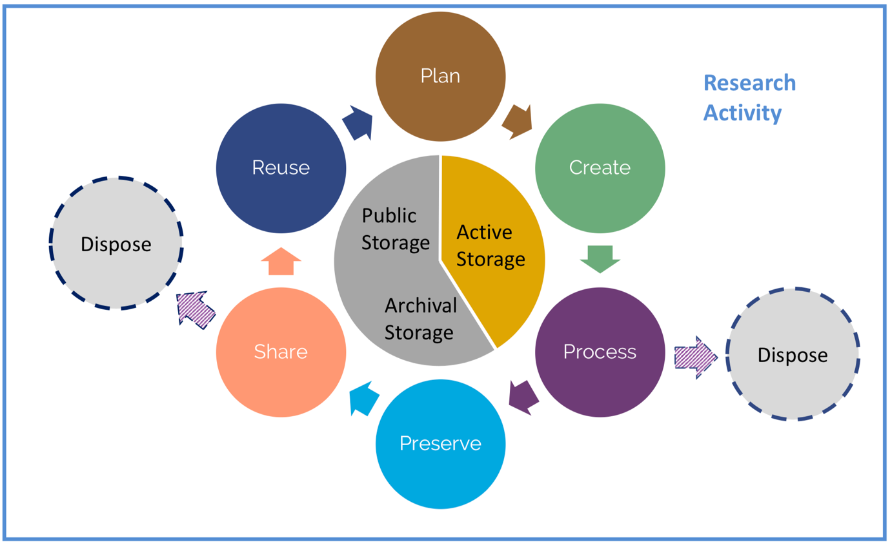
Figure 1. Data lifecycle

The aims of our data management plan are to:
- Make informed decisions to anticipate and avoid problems in relation to the secure and confidential storage, sharing, use, and disposal of the data
- Avoid duplication, data loss or security breaches
- Develop procedures early on for consistency
- Ensure data are accurate, complete, reliable, and secure

1. What data will be produced?
Does the data already exist?
We ran a search on the re3data.org website with the keywords immigrant, migrant, digital, cultural activities, heritage, heritage language. No relevant existing data sources were found.

The following data will be produced as part of Output 1: Understanding requirements study.
- Audio-recordings of conversations during workshops lasting 3-5 hours (e.g. focus group discussions). The data will be recorded as MP3 or .Wav files. Each workshop will produce about 200MB to 2G of data depending on the file format and length. 1 or 2 workshops will run separately in each country (Spain, Turkey, Finland, UK) depending on the number and availability of the participants.
- A summary of the main points raised during the workshops (2-5 pages). The project researchers in each country will listen to the audio recordings and write the summaries in English. The file format will be .doc or .docx. 4 summary documents will be produced (each about 100 KB).
- Observation notes taken during the workshop by the project researchers in English. The file format will be .doc or .docx. 4 observation notes documents will be produced (each about 100 KB). The notes may be accompanied by photographs taken during the workshop. The file format will be JPEG (.jpeg, .jpg) or PNG (.png), each with a file size of about 250 KB. We expect about 10-20 photographs to be taken at each workshop.
- 360 videos created by the participants during the workshops. Participants will upload these as private videos on the project Youtube channel. Each video will last 30 seconds to 1 minute. The file format will be a 360 video file format, e.g. .insv. A 360 video of about 1 min length produces a file size of about 400MB. A total of 32 videos will be uploaded.
- URLs of the H5P interactive activities created by the participants on h5p.org during the workshops. The URLs will be copied and pasted on a text file by the researchers. The file format will be .doc or .docx. 4 documents will URLs will be produced (each about 10 KB).

We will not collect any personal data that may identify the individuals who participate in the study.
2. How will you document your data?
In order to ensure that data is produced with similar standards, we have produced a step-by-step procedures document to be used in each country. We will store the procedures document along with the data.
When reporting, we will include information on the research context, design, and methods.
When labelling the data, the following formula will be used:
- Audio recordings: [partner initials]_IO1workshop_audio_[number] (e.g. UH_IO1workshop_audio_1)
- Summary of main points: [partner initials]_IO1workshop_summary (e.g. UH_IO1workshop_summary)
- Observations: [partner initials]_IO1workshop_observation (e.g. UH_IO1workshop_observation) & accompanying photographs [partner initials]_IO1workshop_observation photo [number] (e.g. UH_IO1workshop_observation photo 1)
- 360 videos: These will be uploaded on Youtube by each participant using a title [partner initials]_IO1workshop_[a number to identify the participant] (e.g. UH_IO1workshop_1)
- URLs for H5P activities: [partner initials]_IO1workshop_URL (e.g. UH_IO1workshop_URL)

3. How will your data be managed, structured and stored?
- Each partner will store the audio recording(s) of the workshop in a secure and password protected computer. The audio files will not be shared with the other project partners.
- The summary files, observation sheets (any accompanying photographs), and the document that lists the URLs will be stored on the project Microsoft Teams space hosted on Newcastle University servers. The files will be uploaded under the relevant folder for Output 1 data.
- 360 videos created by the workshop participants will be stored on the project Youtube channel.
4. What data and how will it be archived and shared?

All data files will be deleted 5 years after the project completion, except the audio files, which will be deleted once the Output 1 study report is finalised. This applies to both the data stored on the Microsoft Teams space and the data stored locally in each partner country.

Following analysis of the Output 1 data, a report will be produced to share the findings with other interested parties. The report will be freely accessible on the project website. The report may include anonymised data extracts.

A record of all the data produced by this project will be created on the Newcastle University data repository (https://data.ncl.ac.uk/) including the types of data, blank ethical forms, and procedures for data collection. However, in line with our ethical duty to protect the participants, which involves vulnerable groups (migrants, refugees, and asylum seekers), we will not share any data with researchers outside the project group.
5. Who has responsibility for implementing the DMP?
The project PI (Newcastle University) is responsible for implementing the DMP, and ensuring that it is reviewed and revised. Newcastle University is also responsible for ensuring secure storage, archiving, and deletion of the data on the Microsoft Teams file share space.
Each partner institution is responsible for implementing the DMP in their own countries and ensuring that the files on the Microsoft Teams file space are not shared by third parties.
Each partner institution is responsible for secure storage, archiving, and deletion of the data stored in their own computers.

