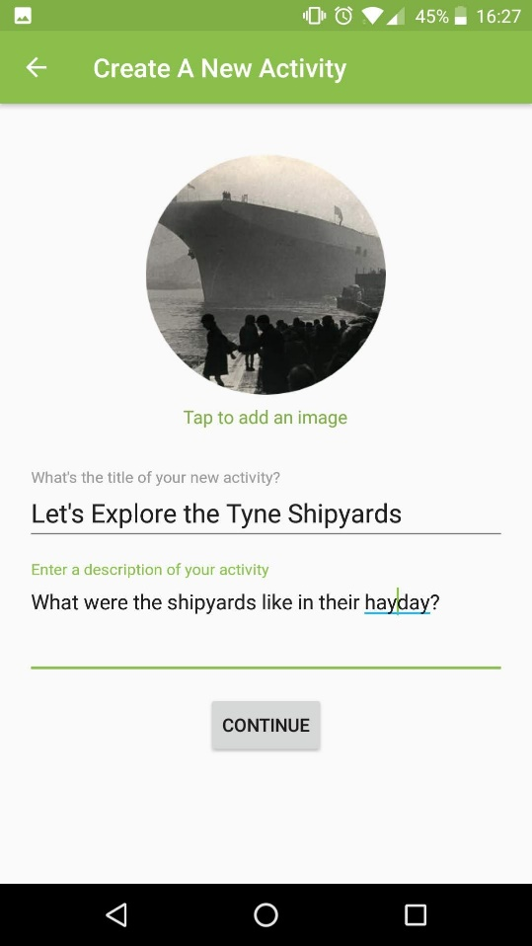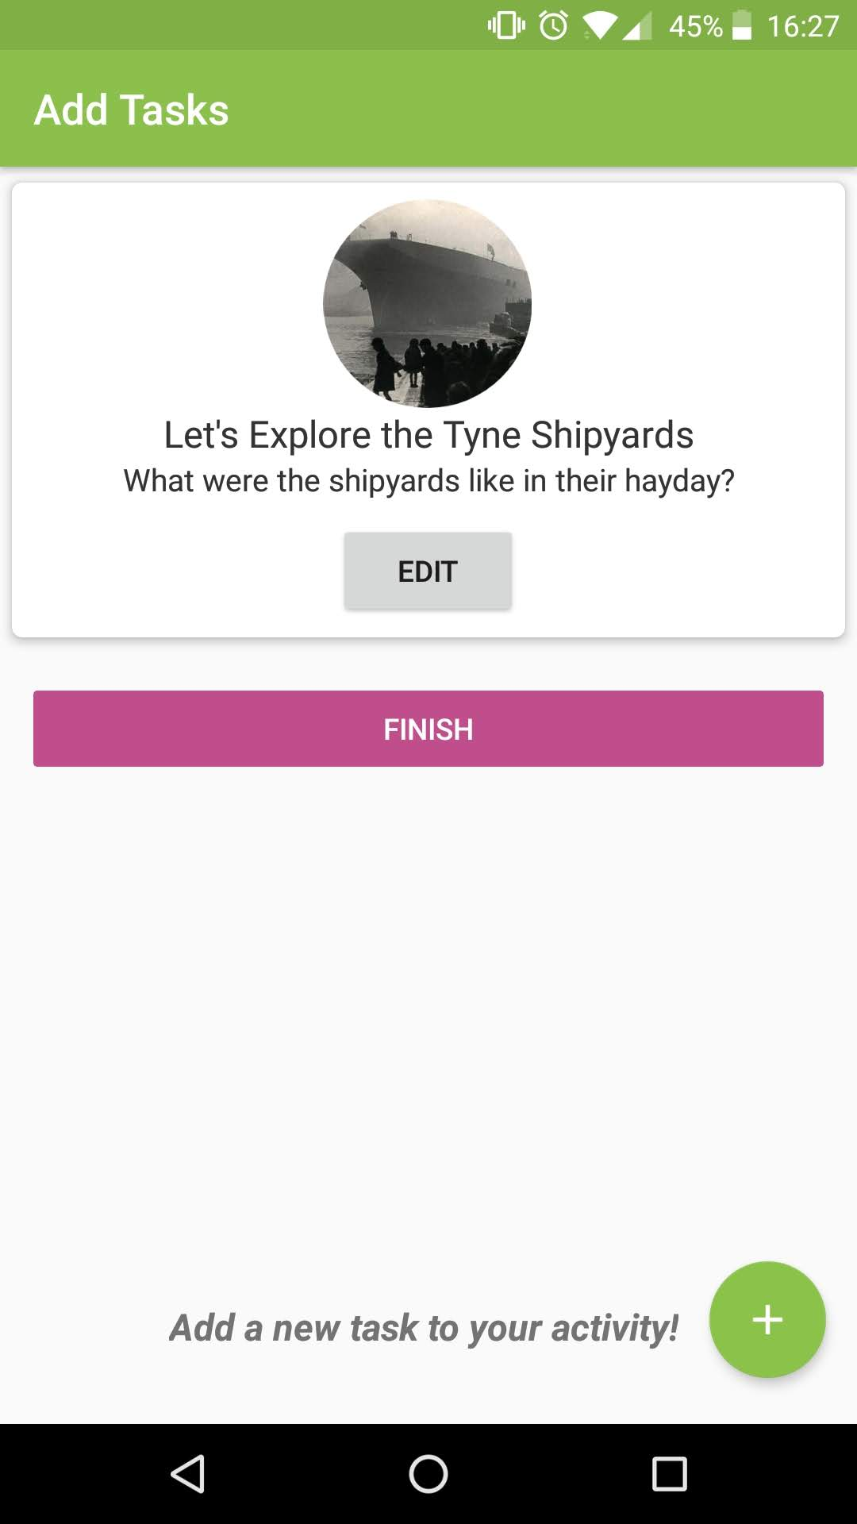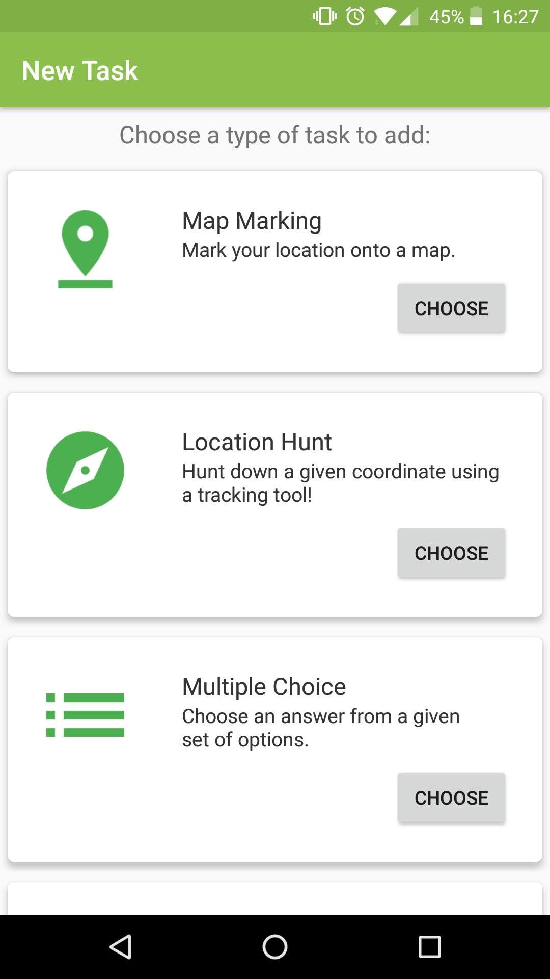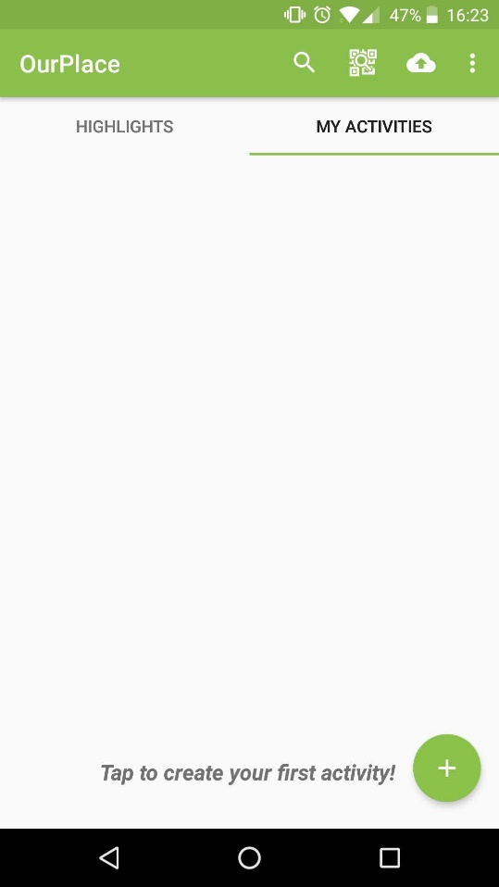

There are many types of tasks, which will ask the user to do different things. Choose a type of task to create.

The next step is to add tasks to your activity. Add new tasks by pressing the plus button. You can add as many as you want.

Enter the name of your activity, a description of what it’s about and an eye-catching image

Create a new activity by going to the ‘My Activities’ tab and pressing the plus ( + ) button

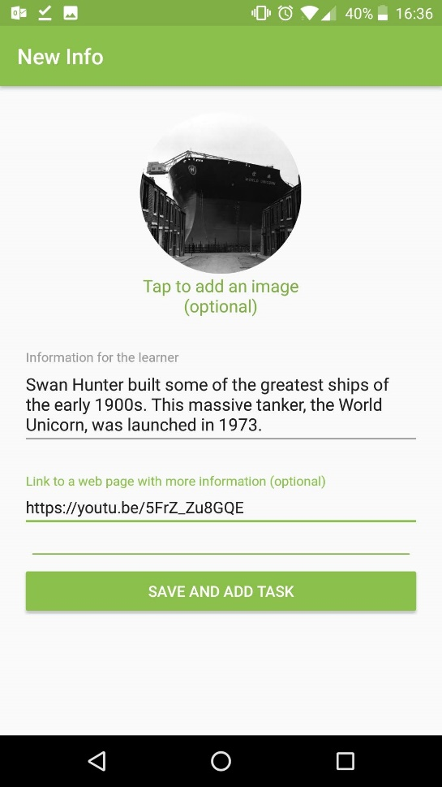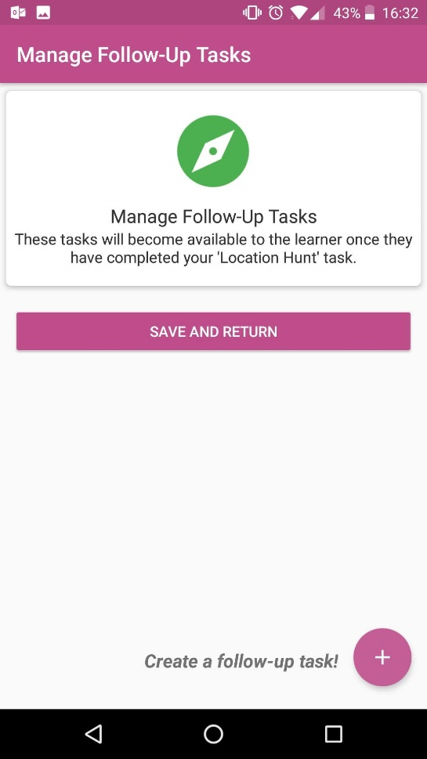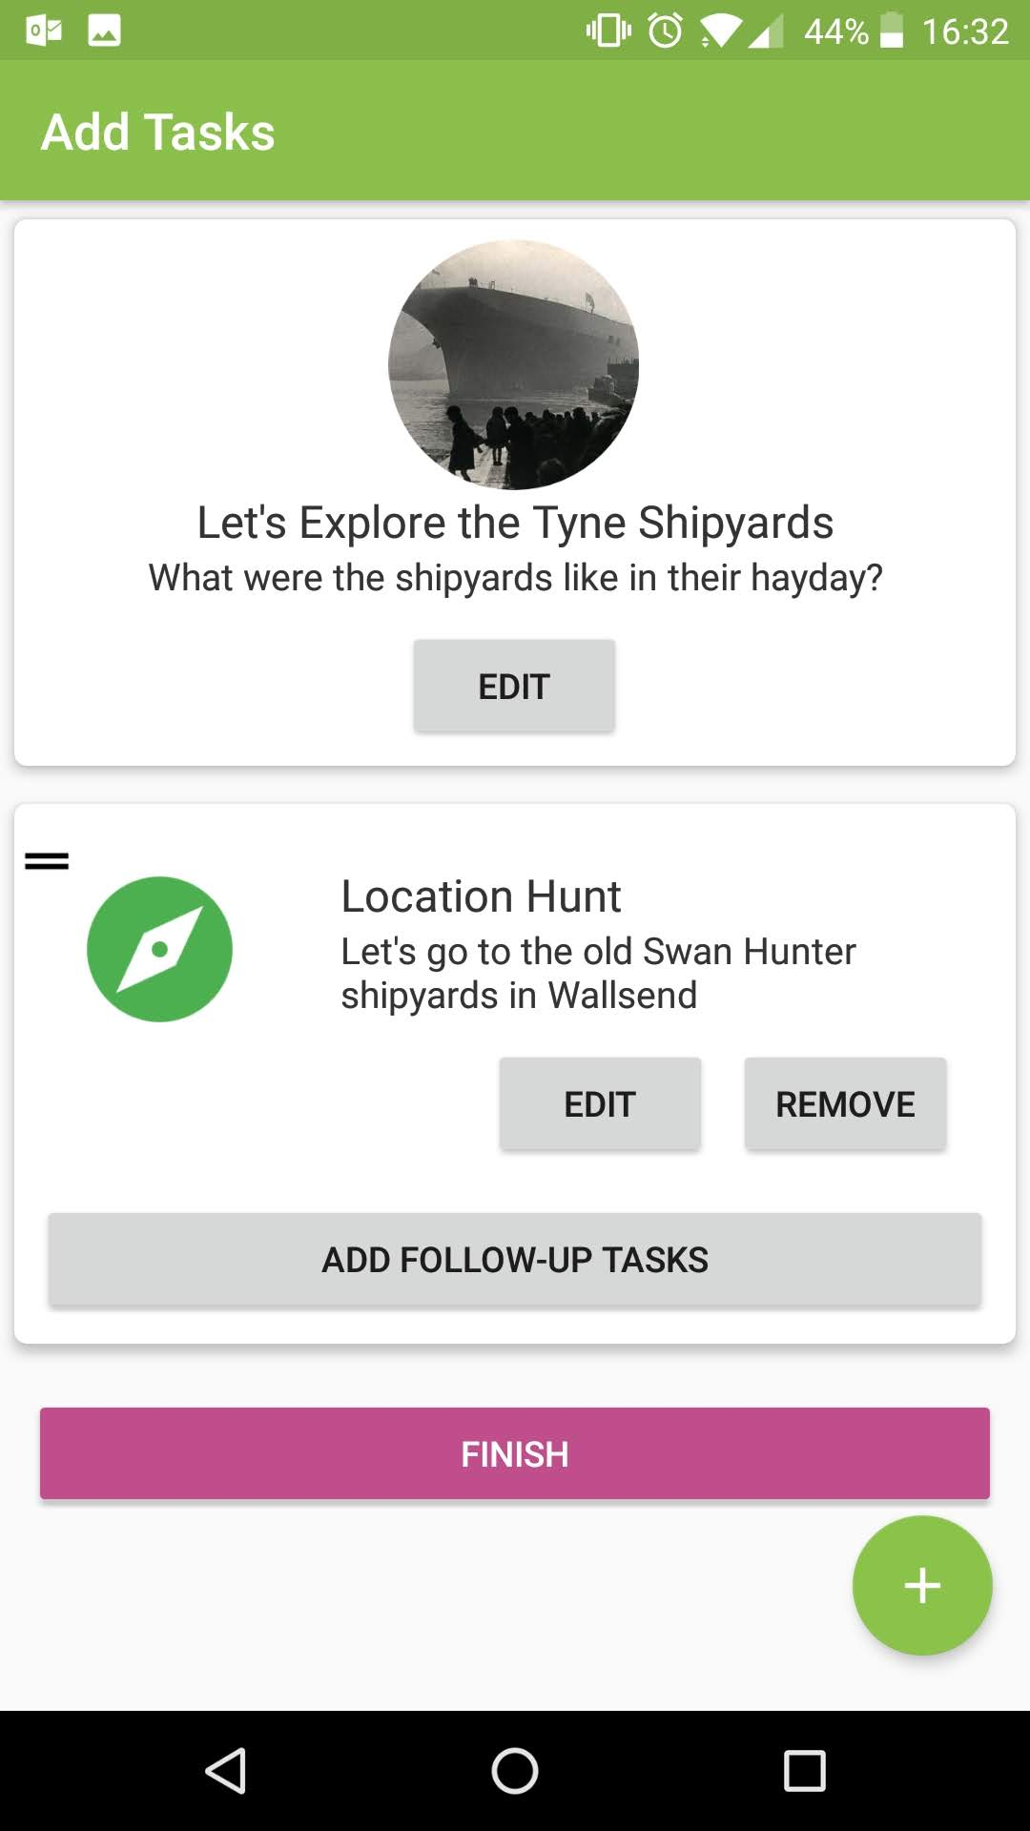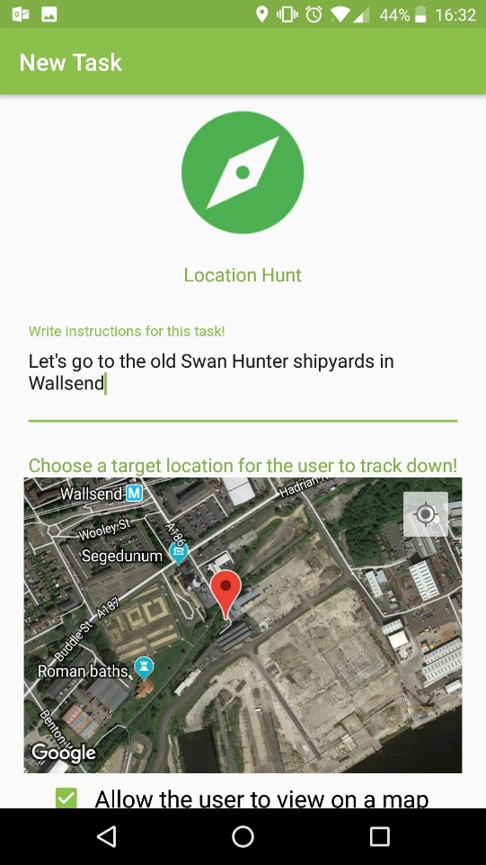

I’ve created an ‘information’ task about the shipyards. It simply gives the user a photo to look at, text to read and an optional link to a webpage.

Each task requires a written description or instruction. Some task types require more information. This ‘Location Hunt’ task requires you to choose a location for the user to find. Click ‘save and add task’ when done.

Created tasks appear as a list in your activity. You also can add ‘follow-up’ tasks which appear when the user has completed them.

Press ‘add follow-up task’. Let’s have the user do something when they find the location.

Follow-up tasks work exactly the same as normal tasks, they’re just hidden to the user at first.

Press the plus button to add a new one.

As with normal tasks, you can add as many ‘follow-up’ tasks as you’d like.

Once you’ve added all of them, tap ‘Save and Return’

I’m pretty happy with my activity - I’ve added a few more tasks and checked my spelling. Your activity can be as long or short as you’d like it to be.

When you’re happy with yours, tap ‘Finish’

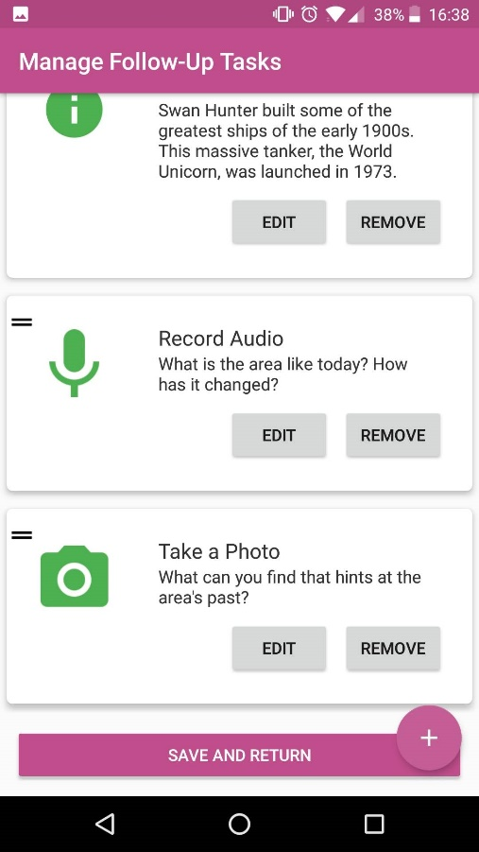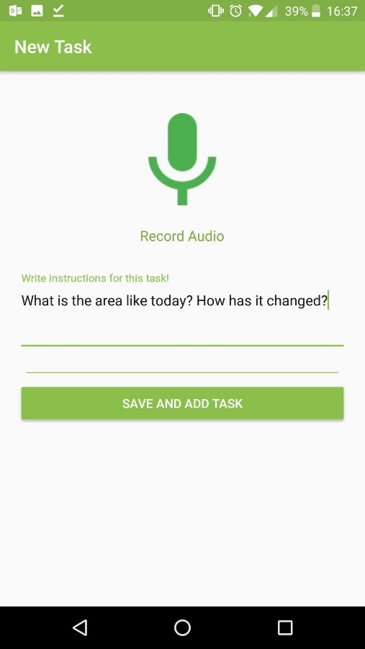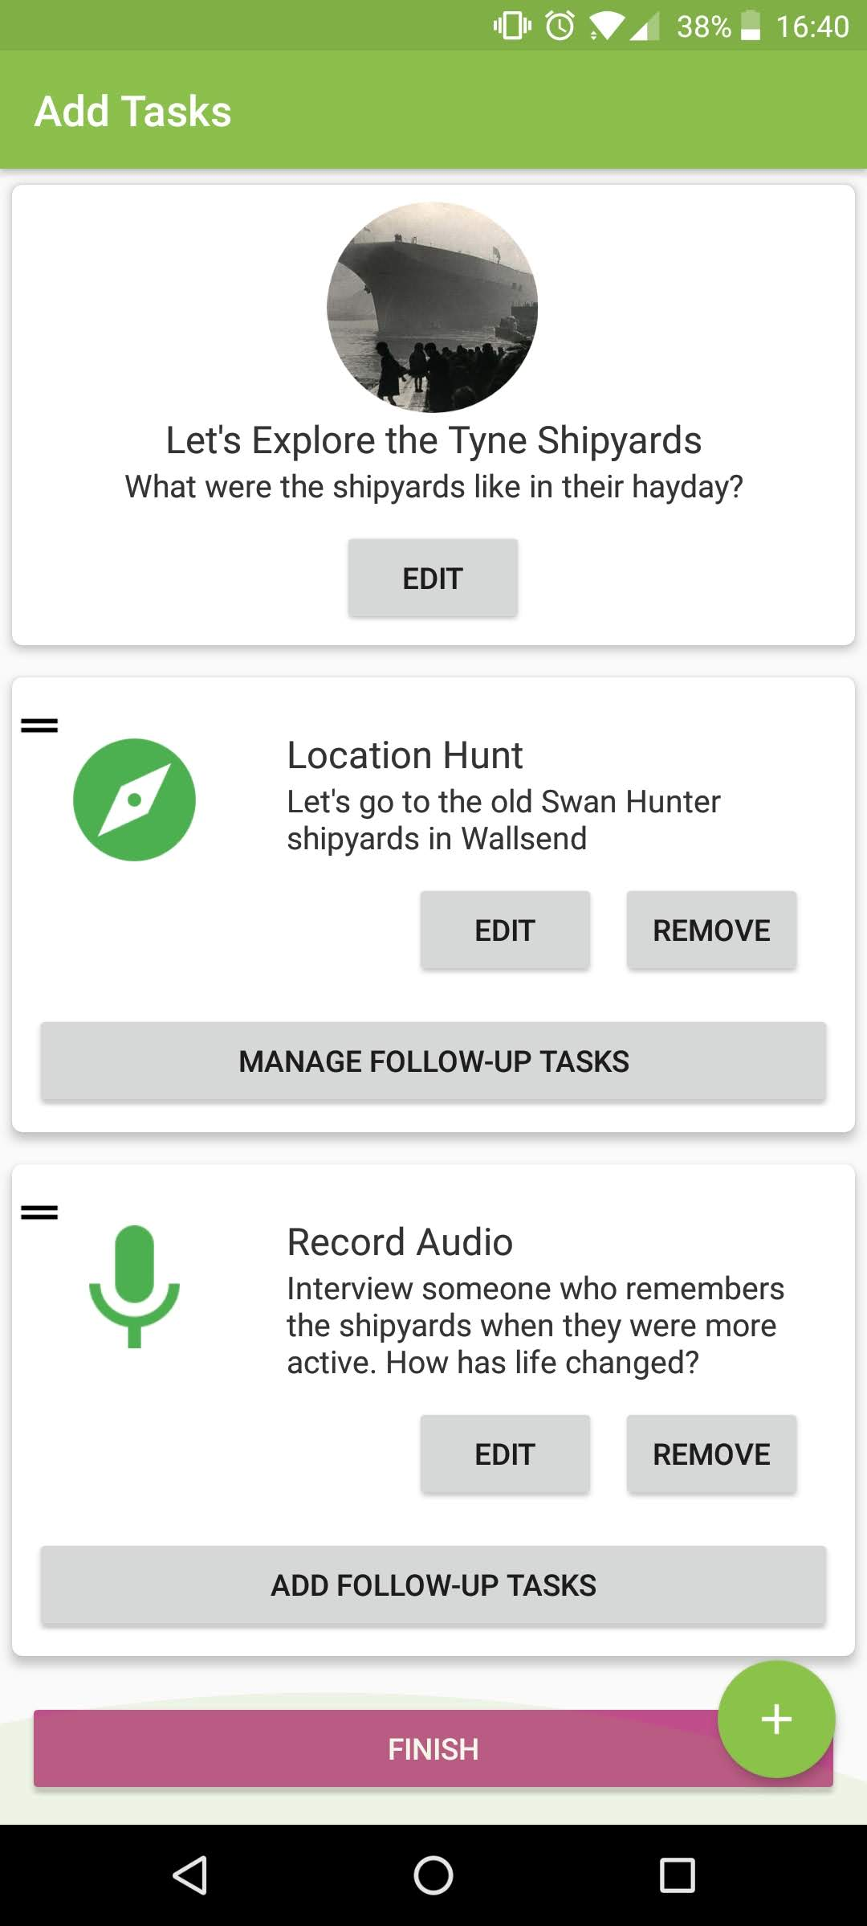

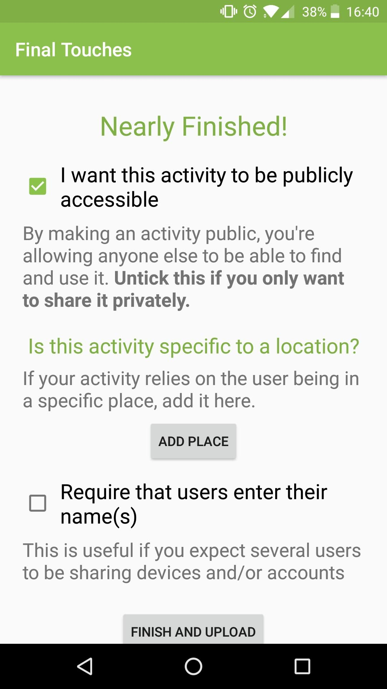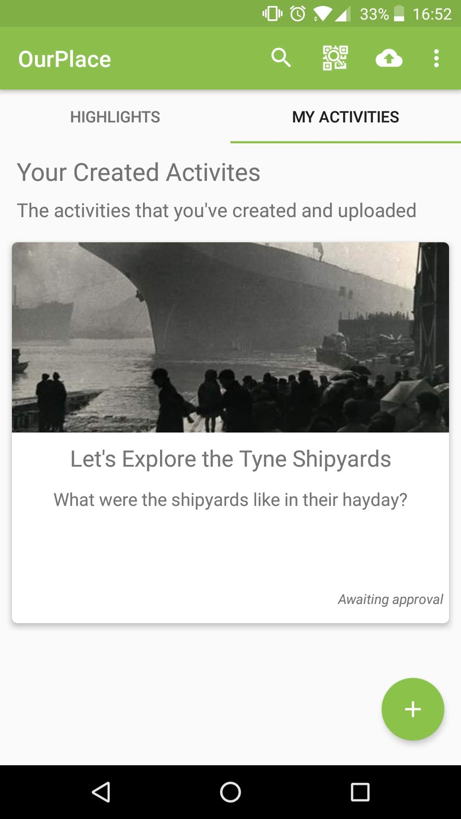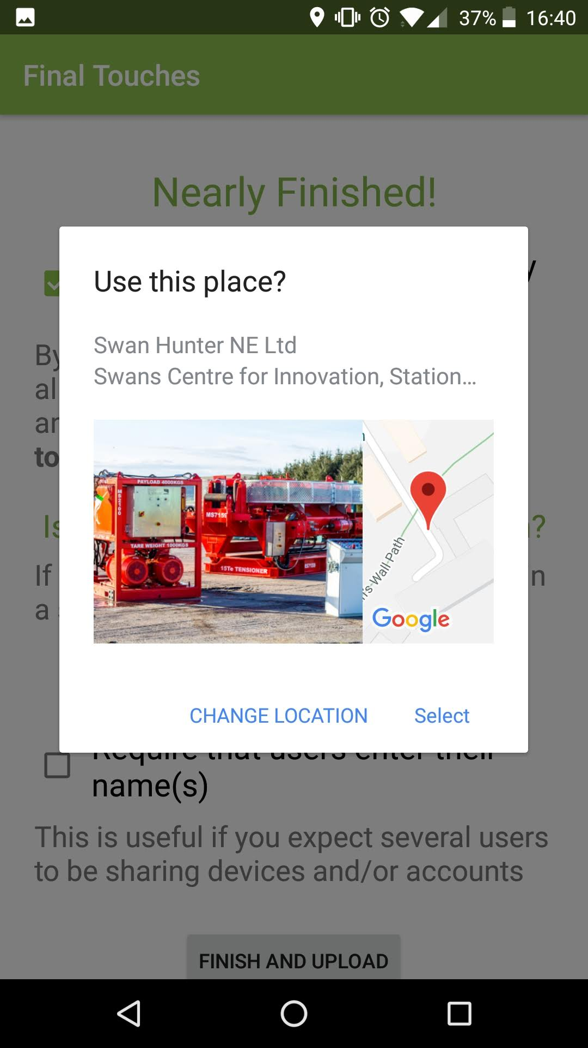

This last page lets you configure your activity.

Keep the checkbox at the top ticked to allow others to access your activity.

Tapping ‘Add Place’ lets you say that your activity is about a particular location. This will help people find your activity if they’re nearby.

Once you’re done, upload your activity and give it a whirl!

Sign into <https://ourplace.app> from your computer to print out any QR codes for your activities.