TABLES
Table 1. List of initial simulation parameters and relevant non-dimensional numbers.
Case | A | B | C | D | E
$${u'}/{S_{L}}$$ | 5.0 | 6.25 | 7.5 | 9.0 | 11.25
$$l/{δ_{th}}$$ | 1.67 | 1.44 | 2.5 | 4.31 | 3.75
$$Re_{t}$$ | 22.0 | 23.5 | 49.0 | 100 | 110
$$Da$$ | 0.33 | 0.23 | 0.33 | 0.48 | 0.33
$$Ka$$ | 8.65 | 13.0 | 13.0 | 13.0 | 19.5

FIGURE CAPTIONS
Figure 1: Distributions of reaction progress variable $c$, non-dimensional temperature $T$ and non-dimensional reaction rate $\dot{ω}×δ_{Z}/ρ_{0}S_{L}$ for turbulent case D with $Le=0.8$, 1.0 and 1.2 at $t={δ_{Z}}/{S_{L}}$, $2{δ_{Z}}/{S_{L}}$, $4{δ_{Z}}/{S_{L}}$, $6{δ_{Z}}/{S_{L}}$, $8{δ_{Z}}/{S_{L}}$ on central $x_{1}-x_{3}$ plane.
Figure 2: Variations of $\tilde{c}\left(1-\tilde{c}\right)$ (solid line) and $\tilde{c^{''2}}$ (dash line) with ${x_{1}}/{δ_{Z}}$ at different time instants for cases A-E (1st-5th columns) and $Le=0.8, 1.0$ and$1.2$.
Figure 3: Variations of $T_{1c}$, ——; $T_{2c}$, ——; $T_{3c}$, ——; $D_{1c}$, ——; $\left(-D_{2c}\right)$, —— with ${x_{1}}/{δ_{Z}}$ at t = ${{4δ}_{Z}}/{S_{L}}$ , ${{6δ}_{Z}}/{S_{L}}$ , ${{8δ}_{Z}}/{S_{L}}$ , ${{10δ}_{Z}}/{S_{L}}$ for turbulent cases A-E with $Le=0.8$, 1.0 and 1.2.
Figure 4: Variations of $\overline{ρu_{1}^{''}{c^{''}}^{2}}$ extracted from DNS data (solid line) along with the predictions of Eqs. 9 (dotted line) and 10 (broken line) with ${x_{1}}/{δ_{Z}}$ at t =${{4δ}_{Z}}/{S_{L}}$, ${{6δ}_{Z}}/{S_{L}}$ , ${{8δ}_{Z}}/{S_{L}}$ , ${{10δ}_{Z}}/{S_{L}}$ for turbulent cases A-E with $Le=0.8$, 1.0 and 1.2. Please refer to the table in Fig. 2 for the colour scheme.
Figure 5: Variations of $\overline{ρu_{1}^{''}c^{''}}$ extracted from DNS data (solid line) along with the predictions of Eqs. 14 (dotted circle line) and 15 (broken triangle line) with ${x_{1}}/{δ_{Z}}$ at t =${{4δ}_{Z}}/{S_{L}}$ , ${{6δ}_{Z}}/{S_{L}}$ , ${{8δ}_{Z}}/{S_{L}}$ , ${{10δ}_{Z}}/{S_{L}}$ for turbulent cases A-E with $Le=0.8$, 1.0 and 1.2. Please refer to the table in Fig. 2 for the colour scheme.
Figure 6: Variations of $T_{3c}$ extracted from DNS data (solid line) along with the predictions of Eqs. 18 (dotted circle line) and 20 (broken triangle line) with ${x_{1}}/{δ_{Z}}$ at t =${{4δ}_{Z}}/{S_{L}}$ , ${{6δ}_{Z}}/{S_{L}}$ , ${{8δ}_{Z}}/{S_{L}}$ , ${{10δ}_{Z}}/{S_{L}}$ for turbulent cases A-E with $Le=0.8$, 1.0 and 1.2. Please refer to the table in Fig. 2 for the colour scheme.
Figure 7: Variations of ${\overline{\dot{ω}}}^{+}=\overline{\dot{ω}}×δ_{Z}/ρ_{0}S_{L}$ with ${x_{1}}/{δ_{Z}}$ along with the predictions of Eq. 19a at t =${{4δ}_{Z}}/{S_{L}}$ , ${{6δ}_{Z}}/{S_{L}}$, ${{8δ}_{Z}}/{S_{L}}$, ${{10δ}_{Z}}/{S_{L}}$ for turbulent cases A-E with $Le=0.8$, 1.0 and 1.2.
Figure 8: Variations of ${\tilde{ε}}_{c}^{+}={\tilde{ε}}_{c}×δ_{Z}/S_{L}$ obtained from DNS data and the predictions of Eqs. 21 and 24 with ${x_{1}}/{δ_{Z}}$ at t =${{4δ}_{Z}}/{S_{L}}$ , ${{6δ}_{Z}}/{S_{L}}$ , ${{8δ}_{Z}}/{S_{L}}$ , ${{10δ}_{Z}}/{S_{L}}$ for turbulent cases A-E with $Le=0.8$, 1.0 and 1.2. Please refer to the table in Fig. 2 for the colour scheme.

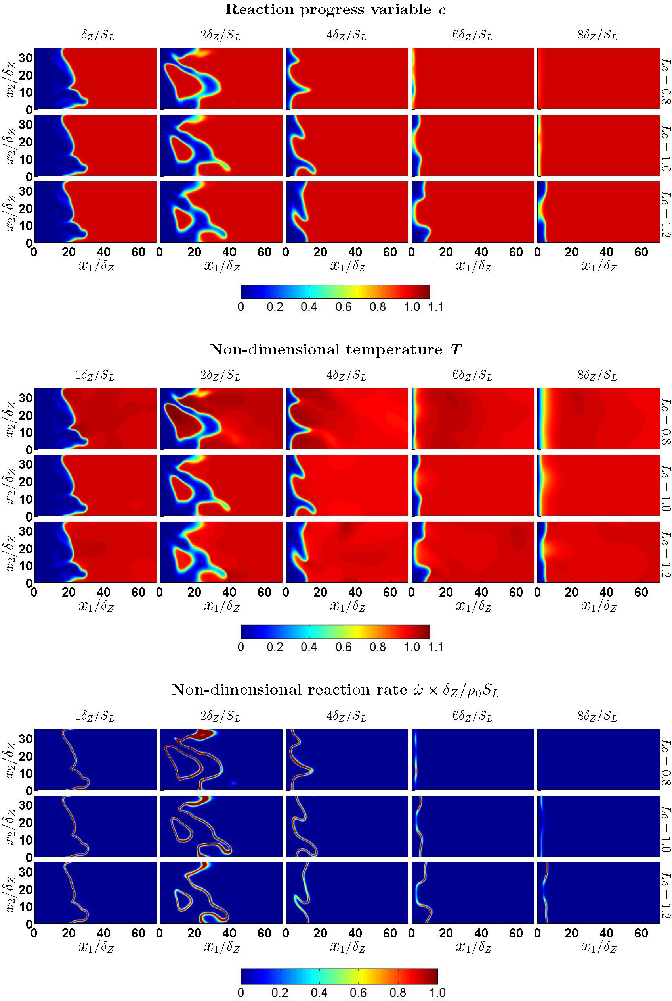
Figure 1: Distributions of reaction progress variable $c$, non-dimensional temperature $T$ and non-dimensional reaction rate $\dot{ω}×δ_{Z}/ρ_{0}S_{L}$ for turbulent case D with $Le=0.8$, 1.0 and 1.2 at $t={δ_{Z}}/{S_{L}}$, $2{δ_{Z}}/{S_{L}}$, $4{δ_{Z}}/{S_{L}}$, $6{δ_{Z}}/{S_{L}}$, $8{δ_{Z}}/{S_{L}}$ on central $x_{1}-x_{3}$ plane.

Figure 2: Variations of $\tilde{c}\left(1-\tilde{c}\right)$ (solid line) and $\tilde{c^{''2}}$ (dash line) with ${x_{1}}/{δ_{Z}}$ at different time instants for cases A-E (1st-5th columns) and $Le=0.8, 1.0$ and$1.2$.

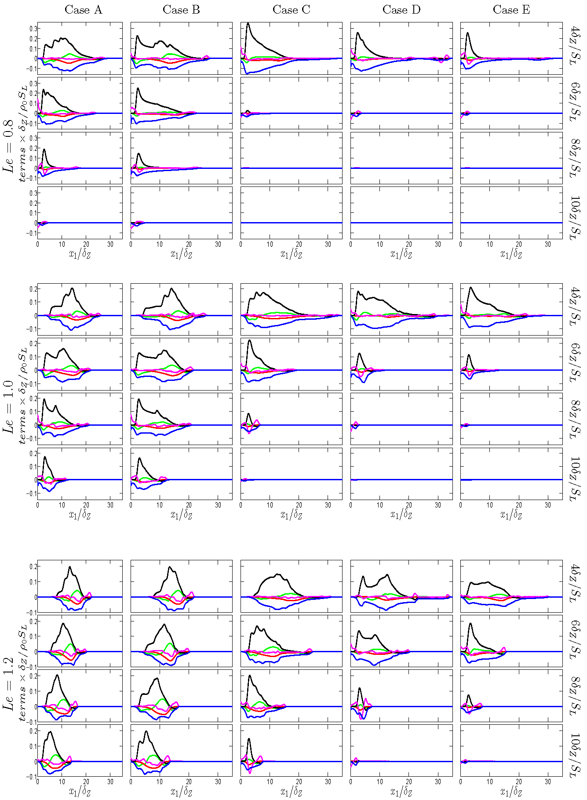
Figure 3: Variations of $T_{1c}$, ——; $T_{2c}$, ——; $T_{3c}$, ——; $D_{1c}$, ——; $\left(-D_{2c}\right)$, —— with ${x_{1}}/{δ_{Z}}$ at t = ${{4δ}_{Z}}/{S_{L}}$ , ${{6δ}_{Z}}/{S_{L}}$ , ${{8δ}_{Z}}/{S_{L}}$ , ${{10δ}_{Z}}/{S_{L}}$ for turbulent cases A-E with $Le=0.8$, 1.0 and 1.2.

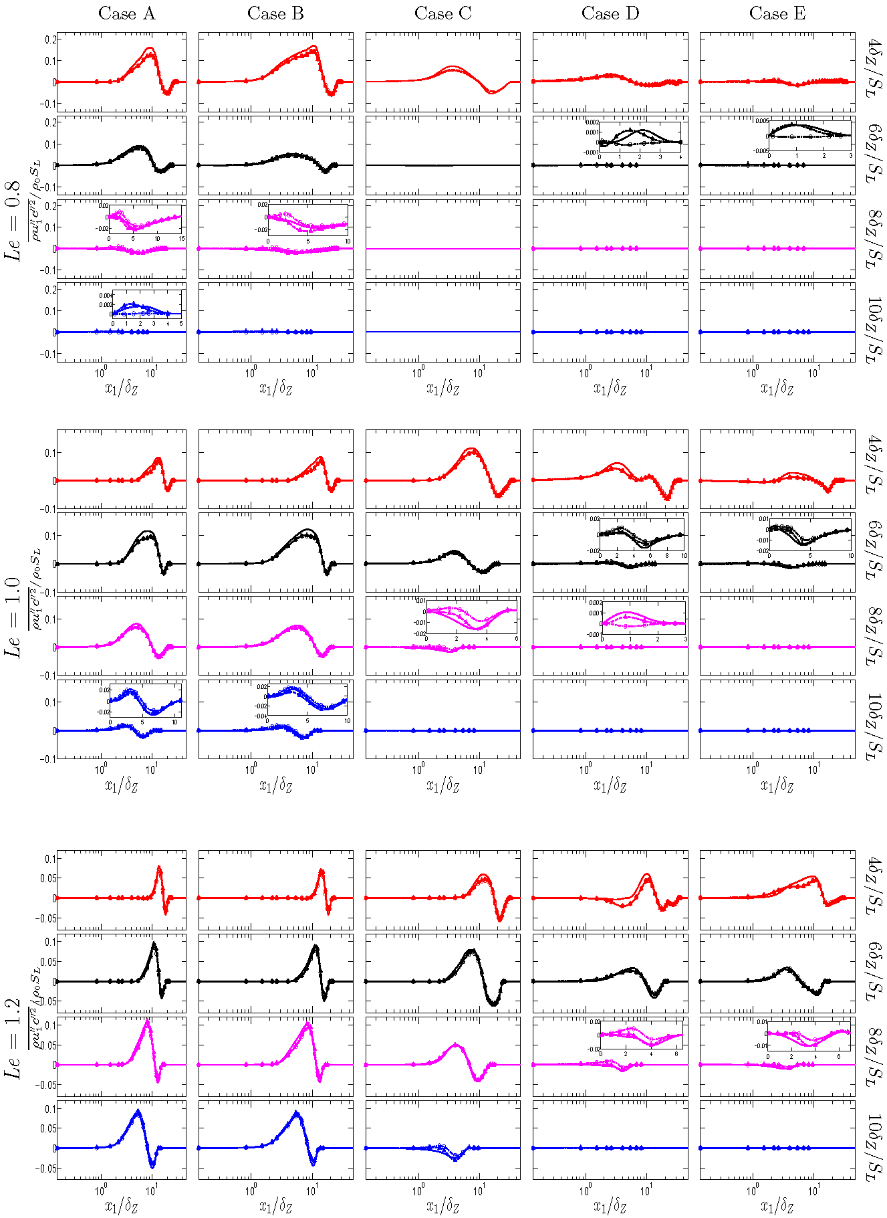
Figure 4: Variations of $\overline{ρu_{1}^{''}{c^{''}}^{2}}$ extracted from DNS data (solid line) along with the predictions of Eqs. 9 (dotted circle line) and 10 (broken triangle line) with ${x_{1}}/{δ_{Z}}$ at t =${{4δ}_{Z}}/{S_{L}}$, ${{6δ}_{Z}}/{S_{L}}$ , ${{8δ}_{Z}}/{S_{L}}$ , ${{10δ}_{Z}}/{S_{L}}$ for turbulent cases A-E with $Le=0.8$, 1.0 and 1.2. Please refer to the table in Fig. 2 for the colour scheme.

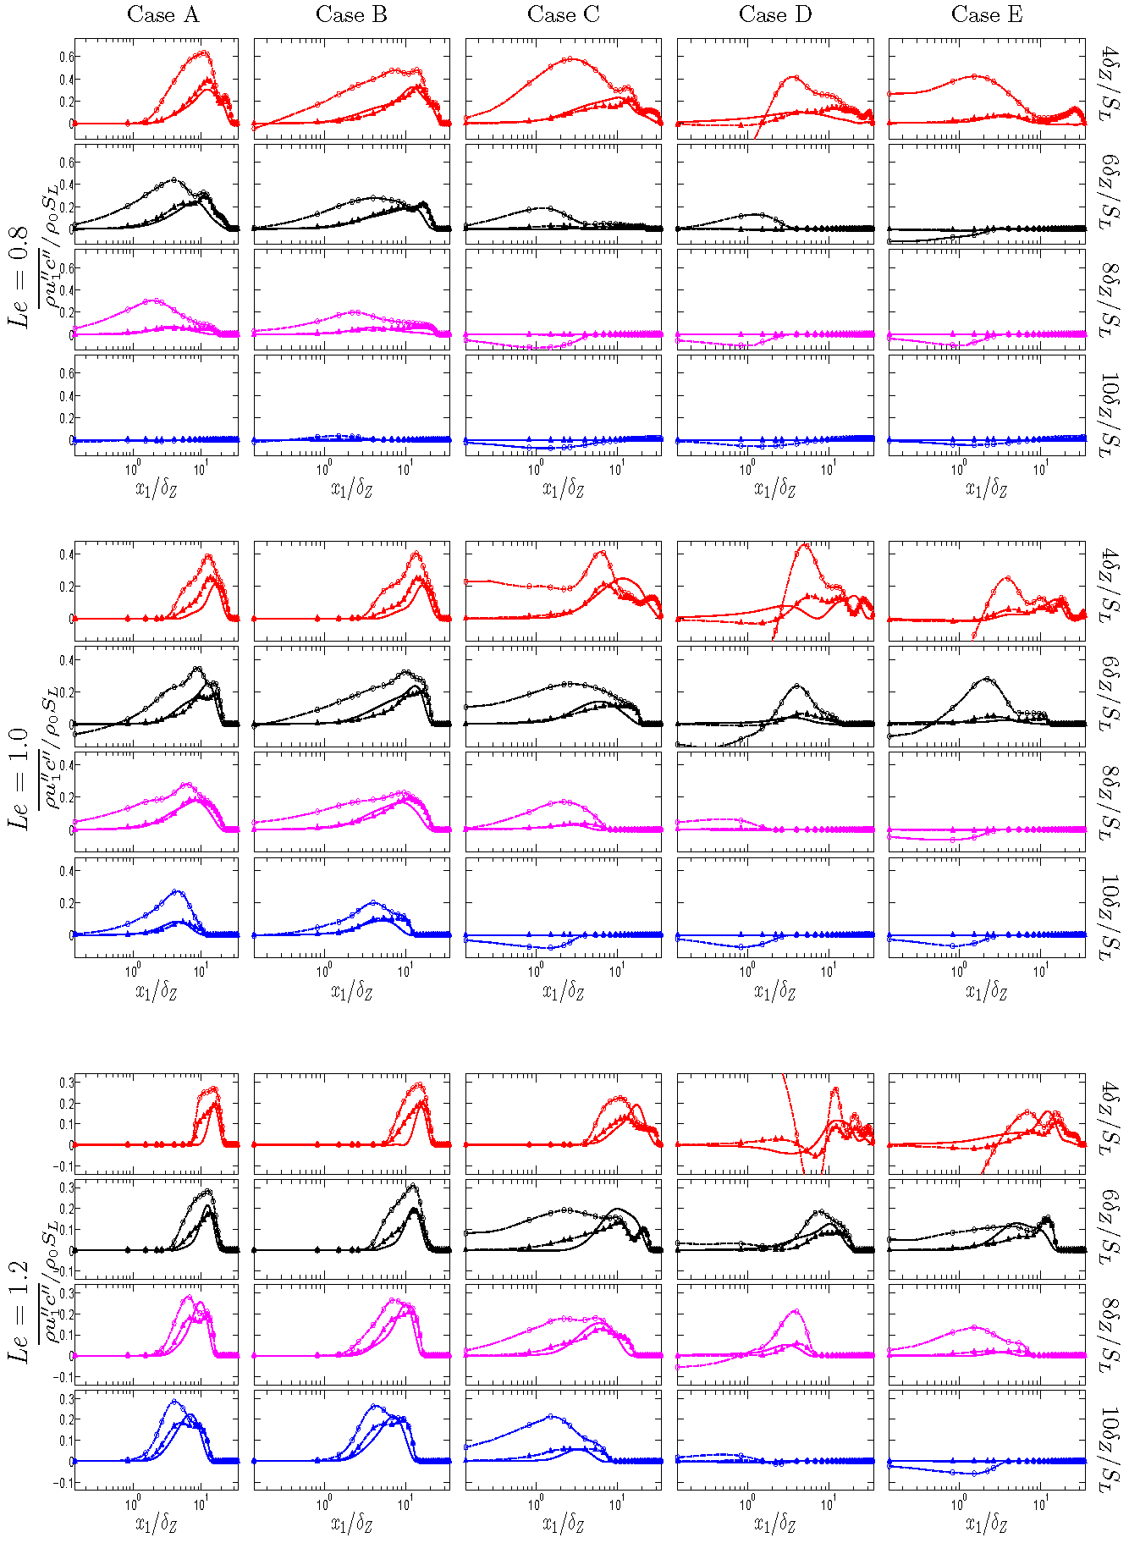
Figure 5: Variations of $\overline{ρu_{1}^{''}c^{''}}$ extracted from DNS data (solid line) along with the predictions of Eqs. 14 (dotted circle line) and 15 (broken triangle line) with ${x_{1}}/{δ_{Z}}$ at t =${{4δ}_{Z}}/{S_{L}}$ , ${{6δ}_{Z}}/{S_{L}}$ , ${{8δ}_{Z}}/{S_{L}}$ , ${{10δ}_{Z}}/{S_{L}}$ for turbulent cases A-E with $Le=0.8$, 1.0 and 1.2. Please refer to the table in Fig. 2 for the colour scheme.

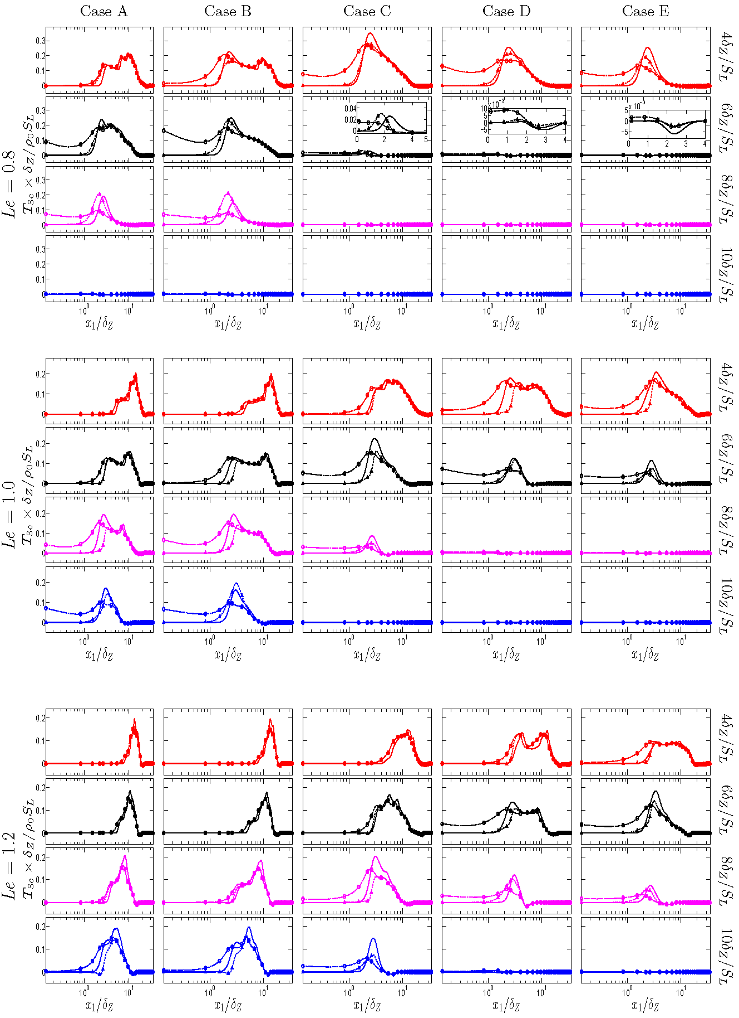\
Figure 6: Variations of $T_{3c}$ extracted from DNS data (solid line) along with the predictions of Eqs. 18 (dotted circle line) and 20 (broken triangle line) with ${x_{1}}/{δ_{Z}}$ at t =${{4δ}_{Z}}/{S_{L}}$ , ${{6δ}_{Z}}/{S_{L}}$ , ${{8δ}_{Z}}/{S_{L}}$ , ${{10δ}_{Z}}/{S_{L}}$ for turbulent cases A-E with $Le=0.8$, 1.0 and 1.2. Please refer to the table in Fig. 2 for the colour scheme.

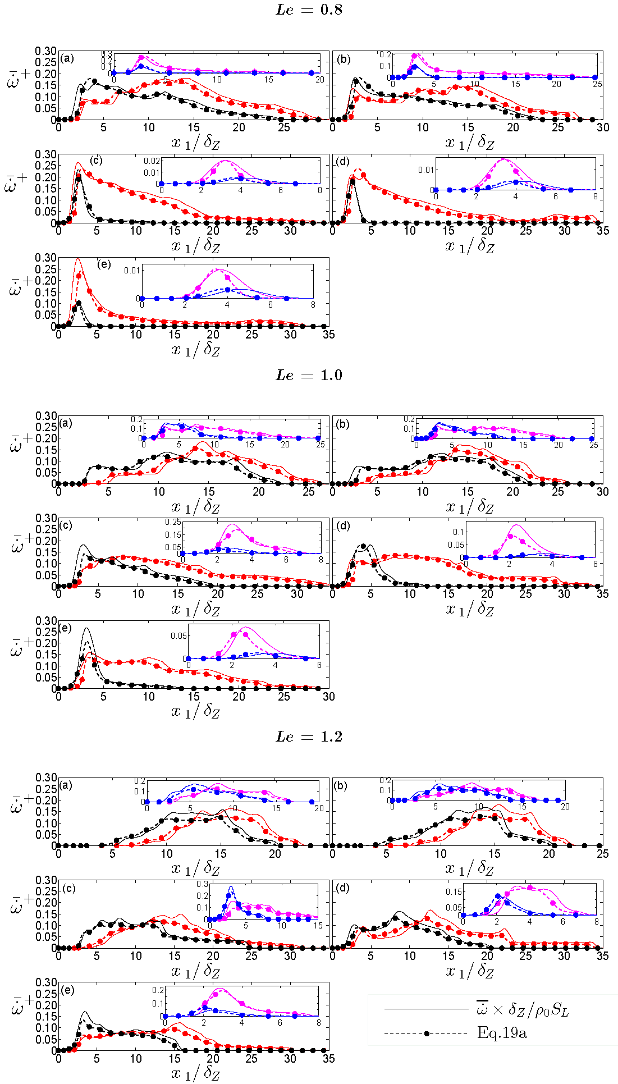
Figure 7: Variations of ${\overline{\dot{ω}}}^{+}=\overline{\dot{ω}}×δ_{Z}/ρ_{0}S_{L}$ with ${x_{1}}/{δ_{Z}}$ along with the predictions of Eq. 19a at t =${{4δ}_{Z}}/{S_{L}}$ , ${{6δ}_{Z}}/{S_{L}}$, ${{8δ}_{Z}}/{S_{L}}$, ${{10δ}_{Z}}/{S_{L}}$ for turbulent cases A-E with $Le=0.8$, 1.0 and 1.2.
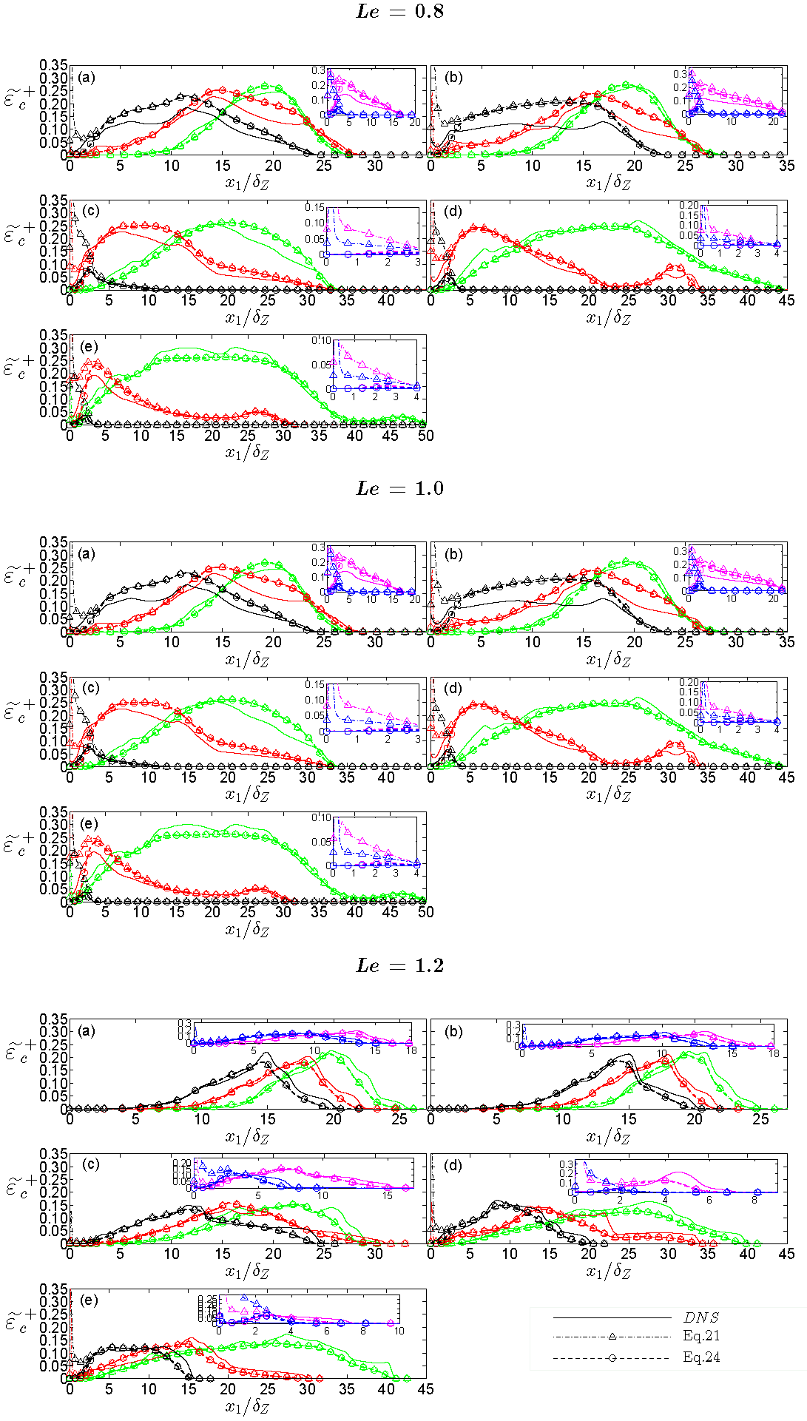
Figure 8: Variations of ${\tilde{ε}}_{c}^{+}={\tilde{ε}}_{c}×δ_{Z}/S_{L}$ obtained from DNS data and the predictions of Eqs. 21 and 24 with ${x_{1}}/{δ_{Z}}$ at t =${{4δ}_{Z}}/{S_{L}}$ , ${{6δ}_{Z}}/{S_{L}}$ , ${{8δ}_{Z}}/{S_{L}}$ , ${{10δ}_{Z}}/{S_{L}}$ for turbulent cases A-E with $Le=0.8$, 1.0 and 1.2. Please refer to the table in Fig. 2 for the colour scheme.

