Reflective notes

HOUSING FILMING: Monday 25th July

- I met P2 his workplace, BCDT, at 1.30pm on Monday. When I arrived, P3 had also decided to join the day of filming.
- There was an interesting conversation between Julien and Brian in progress. They were talking about potential sites that could be improved and developed for housing and how there should be a joint plan for 10 sites to make sure the developers make best use of the space.
  - P3: “There needs to be some kind of overarching strategy or developers just put affordable housing at the rubbish parts of the site or don’t even bother at all”
  - P2: “I can see your point but it’s just not that simple..”
  - P3: “Why not?! It should be. The council should be looking to do it or you just end up with scattered development with no strategic idea behind it”
  - P2: “But if you do a plan like that just as a council or as residents or as a town council, that’s fine – but no developer would sign up to it. If you put all these expectations and rules on the site, the developers won’t do anything at all. If you were going to do it, it would need to be in collaboration with the developers and does become more difficult but it would at least ensure it was viable for them”
  - P3: “But there are developers who would stick to the plan…you know, more local ones…”
- At this point, the conversation began to turn to a debate and P2 was conscious he did not want this to happen. He began to close the conversation down.
- Once the conversation came to a close, I began the workshop. I felt quite relaxed working with P2 knowing his background and he was quite keen to take part. Although P3 had been keen to take part, he is more of a tough character – very loud and opinionated. He had previously raised lots of issues in steering group meetings often arguing with other group members. I was very aware of this and I was keen to build a relationship with him to avoid confrontation of that nature.
- I explained, again, what my research was about – making it clear that there were two parts to it regarding the app and the idea of using video. I also explained in more detail what Bootlegger is, paying attention to the app and the website – explaining its functionality and the benefits of using it. I also made it clear that the app was being tested in this process, that I hadn’t developed it and I wanted them to be as honest as possible about the app. I made a conscious decision to provide more detail about this for P2 and P3 based on learning from the workshop with P1.
- I told them briefly about the work I had done with P1 the previous week. I told them how he was keen to go out and film and he had an idea of where he wanted to film so we just went for it. Then at the end of the day he was less sure about what he had recorded and what he had said and felt it would be better to have more of a structure. I used this to justify spending some time planning before going off to film.
- With the post-it notes and pens, I asked four questions – what is the overall aim, what are the key messages, what are the key issues and who is the audience?
- P3 asked me if the audience was for potential investors and I redirected the question back to him and P2 to make the decision.
  - P2: “I don’t think it should be focused on investors at this stage. Maybe in the future…”
  - P3: “So not to try and attract investors or bring more money into the town for housing?”
  - P2: “Not yet. I think it should be more focused on community engagement with the public. That should be audience”
- I reassured P3 that there’s no reason that in the future, other videos for other purposes couldn’t be produced.
- P2 and P3 began to write things onto post-its after I encouraged them to jot any and all of their ideas down. P2 wrote most of the notes, P3 only wrote a couple
- Once we could see what they had written, I started to talk to them about the order they would like to film it in, what should come first etc. And as we talked it through, I began to rearrange the post-it notes into a storyboard format. As we talked there were a couple of issues that came out which hadn’t been written down and I jotted them down so they could be included in the storyboard. They then began to think of places to film and where we should go.
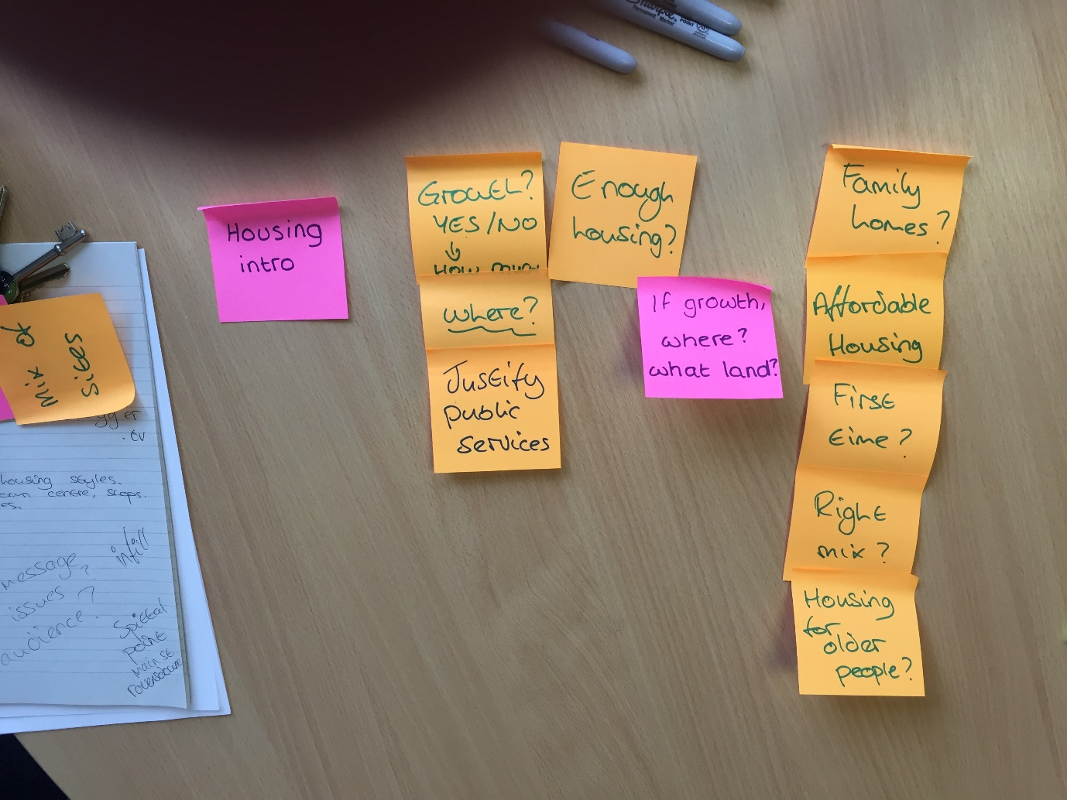
- They were then keen to go out and film. Before we did, I demoed the app to them, showing them the interface, how to use it and explaining the reasoning behind some of the functionality. I picked out a couple of things which I had already noticed needed to change, such as the size of the icons, so they knew I was open to criticisms about the app.
- We went out to film. P2 and I travelled together and followed P3 to the different locations. At each location we stopped to film. P2 and P3 decided together to do two shots of every area – one with speaking and one without. This meant they had flexibility in future to use the videos without the voiceover in different ways.
- It was quite windy that day so we were unsure how clear the voiceover would be, and P2 tried using my headphones to see if that would be any clearer.
- P2 struggled with all of the clips to decide what to say as the voiceover. In most cases, it took at least two attempts to get something that he was happy with.
- I noticed as we drove around, P2 did almost all of the filming with P3 only capturing a couple of videos. This was particularly interesting as he is very outspoken and keen to have input but he was much less sure about filming himself.
- Most of the day was driving around existing housing sites from the 1960s and some of the new, exclusive housing sites that were very expensive.
- They often talked about the issues of affordable housing, the types of people that were attracted to the larger housing and the issues of local young people finding suitable housing in the area.
- At the end of the driving around, we visited a council estate to film the housing there. They were keen to do this as they recognised this area as different to the rest of Berwick and wanted to be seen as giving equal attention to different parts of the area.
- P2, P3 and I had a discussion about the day and how they felt it had gone.
- P2 wanted to go away, view the footage and potentially go back out with his own phone to film more after having more time to think about the script.
  - P2: “I don’t think we’ve covered everything, I think we need to go away and think more about this”
  - P3: “Yeah, we’ve included quite a lot but we probably need to look at the footage we have. I think we should get the rest of the group to have some input”
- Both P2 and P3 felt the planning was useful, but they wish they had done more. They also felt my time was better used to plan more with the groups, show them the app then spend less time filming with the group.
- I spent around 3 hours with the group, 1 hour planning, 2 hour filming. But they felt the other way round would be best

