Reflective notes

TRANSPORT FILMING: Wednesday 27th July

- I met with P8 and P9, both of whom I hadn’t previously met at 10am on Wednesday. The meeting was arranged fairly last minute the day before. They had not responded to any emails or any contact before the Tuesday but at 4pm on Tuesday 26th they arranged to meet the following morning
- All I know about the group prior to this is that they have developed a comprehensive report for the neighbourhood planning group but it was entirely focused on sustainable transport and does not accommodate car use in any way. Although the steering group were pleased with the sustainability element they identified a clear issue in not considering wider issues of car use in the town.
- We met at a café and I bought coffees and found an empty table in a quiet spot. As I had not met them before I began by introducing myself and giving an overview of the reason I’m there and why I’m working with Berwick – explaining my research, the idea behind filming and the app
- I immediately note that P8 is a chatty person who gets easily side-tracked and can go off topic about unrelated transport issues
- I go through the ethics procedure whilst also demoing the app. P8 instantly decides that the filming side of it isn’t for him as he is not technically minded:
  - P8: “I’m not tech-savvy so maybe [P9] should do this”
- P9 has a smart phone and I notice he starts to search for Bootlegger on the app store while I’m still talking
- They sign the consent forms and I explain that I’ve been spending more time planning with groups than out filming as that’s what others had found most useful.
- To start the storyboard procedure, I ask them to jot down any key issues. P8 notes a couple on post-it notes and P9 writes a few more and we discuss them as they do.
- P9 is very quiet and I’m unsure how he feels about the process but P8 may just be dominating the conversation
- As P8 talks, I realise he is saying a lot of relevant things that could be included in the film so I begin to write things on notes as he talks and as P9 occasionally chips in
- They have recognised that their work thus far is heavily weighted towards sustainable transport methods and they also recognise that they are biased because they are both keen cyclists
- At this stage, I wonder what my role is as facilitator/researcher/planner – as a planner I should question that and suggest they consider car use more, as a researcher I’m unsure, and as a facilitator I should prompt on certain issues
- They provide me with a copy of the objectives they have developed as a transport working group and it becomes obvious that they have clear ideas and this could form the basis of the film.
  - P8: “We need more bike routes that are safe and we need to encourage people to walk into the town centre. Like the people who work in the centre, a lot of them could walk from home to work but they choose to bring the car”.
- The final storyboard uses the objectives from the report as the key issues and messages with topics falling within those
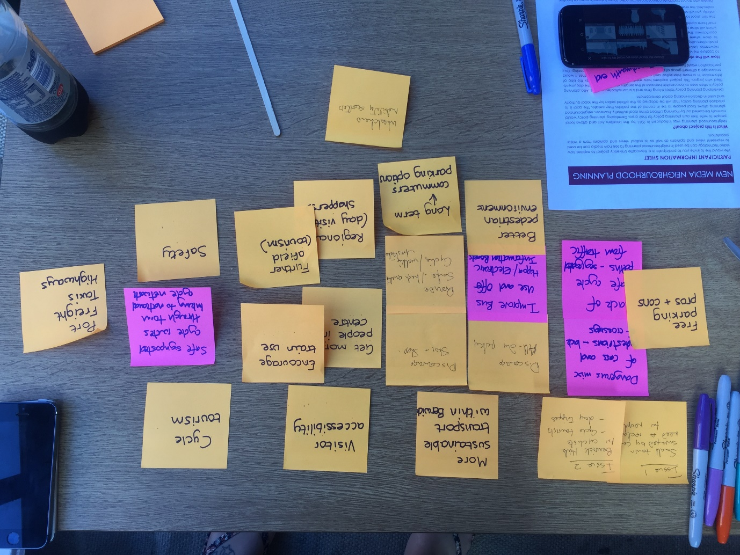
- During this time, I notice (as can be seen in the photo) that P9 has successfully downloaded Bootlegger, logged in and accessed the Berwick shoot without much guidance at all
- We decide to go out to film and start with Bridge Street – P9 takes up the mantle of filming as P8 is still not keen.
- They do one shot with me there for specific guidance and it is clear that P9 is happy with using the app and quite confident.
- After that, they continue to film and I merely observe. Their conversations are all centred around sustainable modes of transport.
- They then ask about the other groups and what they have been doing and where they have been filming
  - P8: “What have the others been doing then? Or is it top secret?!”
  - Researcher: “We’ve done the same activities and started to think about the issues that’s important for that particular group…”
  - P9: “I find it hard in the topic groups. All the topics are so interlinked. Transport – it cuts across everything”
- As we walk round to different locations, I explain what other groups have filmed in that place or what their focus was.
  - P9: “See, sustainable transport is important. But that’s coming from us and we’re both keen cyclists.”
  - P8: “Yes, but we need to make a big change if it is to make a difference”
  - P9: “We do still need to consider cars and lorries. We need a way for lorries to get into the centre for deliveries. Plus, we said we want to encourage people to come here from further afield so we need to make sure they can come here by car”
  - P8: “I suppose so but what about all the people who drive to work when they could walk?”
  - P9: “There’s no easy solution”
  - P8: “I suppose not. And I suppose we do have to consider more than just cycling”
- This was a significant change from the report and the earlier conversations.
- P8 started to get involved with the filming a little and just ‘having a go’ using P9’s phone. He was still unsure about using the app despite being able to use it well.
- P9 often recorded very short clips but P8 though “they’re less daunting”
- We continue to film in and around the area and we continue to discuss sustainability issues.

