Reflective notes

NATURAL ENV. FILMING: Tuesday 26th July

- I met P4 (architect and Green Party Councillor) at a café at 10am on Tuesday. After running two workshops with Berwick so far, I was feeling more confident about my approach and the way to do things. With the second workshop, I had done more planning but the participants still felt it wasn’t enough so with P4, my idea was to do more planning.
- Compared to the other groups, I did feel slightly uneasy, as P4 is quite a reserved character and I never know whether he doesn’t like what we’re doing or not.
- I started the workshop the same way as always, with an explanation of my research, the two aspects to it and the ethics procedures. He asked a lot of questions about the app and its purpose so I began a demo.
- During the demo, he asked lots of questions too in order to fully understand how to use it. He was concerned that he didn’t have his smartphone with him but reassured him that I had phones he could use.
- I began to explain the plan for the workshop. I explained that I was going to do more planning with him if he was okay with it and this was because of feedback from the other groups.
- I asked him the same questions about goal, key messages, audience and key issues – the same question prompts I had used with the housing group.
- I had noticed that many groups instantly think about places they know and places they want to film rather than on the issues so also gave him the option to jot down locations.
- He began writing lots of things on post-it notes of things he wanted to capture such as street nature, beaches, woodlands etc.
- I prompted the discussion once he was done, by asking what the key message was, and as we talked and discussed the film.
- I jotted down key points he was making that he hadn’t already captured on post-it notes. I got the sense from this workshop in particular, but the others too, that they know the key points/what they want to say but don’t realise it. I began to realise that as the groups discussed, I should be jotting down the key points
- I noticed with P4, he was keen to focus on the protection of the natural environment. I gave examples of what other groups had done too and there were some clear conflicts between his philosophy of protection and the idea of growth for the town.
- We had a lot of post-its and I began to help organise them into an order
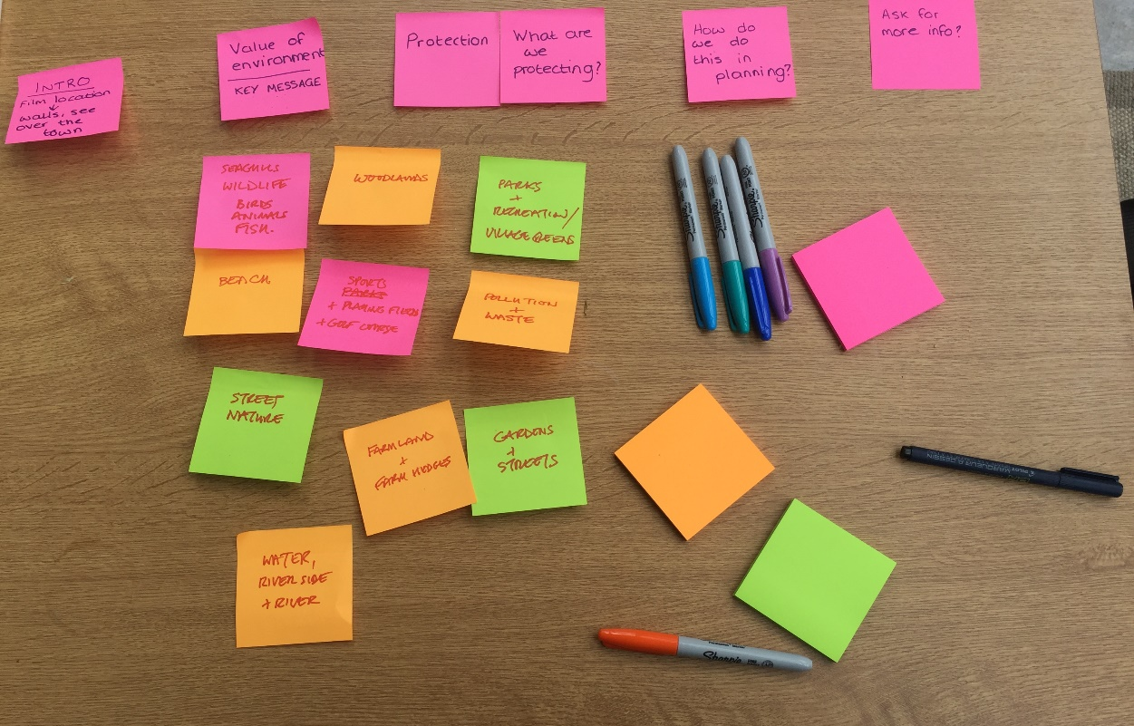
- He then began to think about locations and jotted those down in his notebook.
- We only had a limited amount of time for this workshop as P4 had to get back home but he was keen to do some filming and then do more on his own later.
- I asked if he wanted to spend some time developing ideas of what he would say at the different locations, but he wasn’t sure about doing the voiceover there and then.
  - P4: “Oh, I’m not really sure…I don’t know if I want to do a voiceover. Or at least, I’m not sure I want to do that now. I think I’d rather do some filming and then go back to the wider group and we could maybe work that out together?”
- He preferred to go back the wider working group with the footage he had captured and work on the narrated script with them.
- Once I had showed him to use the app, he was clearly very tech-savvy and was happy to use it on his own.
  - We had arrived at a large playing field leading up to a golf course
  - P4: “You just stay in the car…I’ll jump out and record some film over there and I’ll be back and we can go on to the next place”
- We visited a few key locations before P4 had to leave
  - P4: “Can I download this onto my own phone? Just I’d like to film some of the landscapes when I’m walking the dogs at sunrise.”
  - Researcher: “Yeah, of course. As long as it’s an Android phone or and iPhone”
  - P4: “Great! I’m always out early on the morning and the views are fantastic and it would be great to record that. I’m often out and about so I can continue to record and get some more videos”
- There was a huge focus on protection of the environment. P4 presumes that anything other than protection will have a negative impact – definite conflict between growth agenda and protection
- Happy to use the app – confident very quickly and was keen to do more footage away from the workshop
- Script development needs work with the wider working group

