Reflective notes

BUILT ENV. FILMING: Tuesday 26th July

- I met three of the built environment working group at 2pm on Tuesday. Originally we were meeting in the town centre but because of the need to do more planning work, we met at the town council offices.
- I met with P5 (retired ex-planner, CAG member), P6 (a Conservative Councillor, CAG member), and P7. P5 and P6 are on the core steering group and P7 is part of the wider working group for the built environment.
- Going into this workshop, I felt quite nervous. P5 is very opinionated and because of her planning knowledge is often set in her ways with how things could and should be done. There has been many arguments between her and other members at the steering group in the past. She has more experience in planning than I do, particularly planning policy, and I felt nervous as to how the workshop would go.
- I began by introducing myself and my research (I hadn’t met P7 before) and explaining the purpose of the day. P5 asked a lot of questions
  - P5: “So what is this for? What will the videos be used for exactly?
  - Researcher: “Well, in some ways that’s up to you as a group and as a neighbourhood plan but I would suggest it could help to build the evidence base as part of what you’re currently doing and it can be used for consultation in the future too..”
- P5 and P6 were particularly sceptical and were not satisfied with the answer I provided.
  - P6: “I don’t really see what you mean…”
  - P5: “In what ways?”
  - Researcher: “So, the group needs to engage with the wider community and although meetings and events are great to reach some people, they don’t reach everyone. So, as an example, you could use some of the videos by sharing them on social media and inviting comments that way”
- They were happy with this response and could see the purpose, although they remained visibly sceptical. None of the group use social media so they were “taking my word for it” (P5).
- I gave them the information sheet and consent form and they read through the information asking questions wherever needed. P6 expressed real doubts about using the technology:
  - P6: “I’m not very good with technology”
  - P5: “Me neither”
  - P6: “But [P7] will be good at this. He’s got those fancy smartphones and uses them properly. I’ve got one, but I only really make phone calls. My family are forever showing me what to do”
- Before they signed the consent form, I demoed the app to the group showing them the features and benefits of it and suggesting reasons why it could be useful. As with other groups, I made it clear this was a test and that any feedback on the app was welcomed.
- We began to plan the storyboard before going out to film and P5 and P6 were most engaged. P7 didn’t say much or contribute much.
- I used the same prompts as with the other groups and they wrote a lot of information down onto the post-it notes. And I led them in a short exercise to put them in order and decide on locations just as I had with other groups. I suggested the need for a beginning, middle and an end and explained it as telling a story
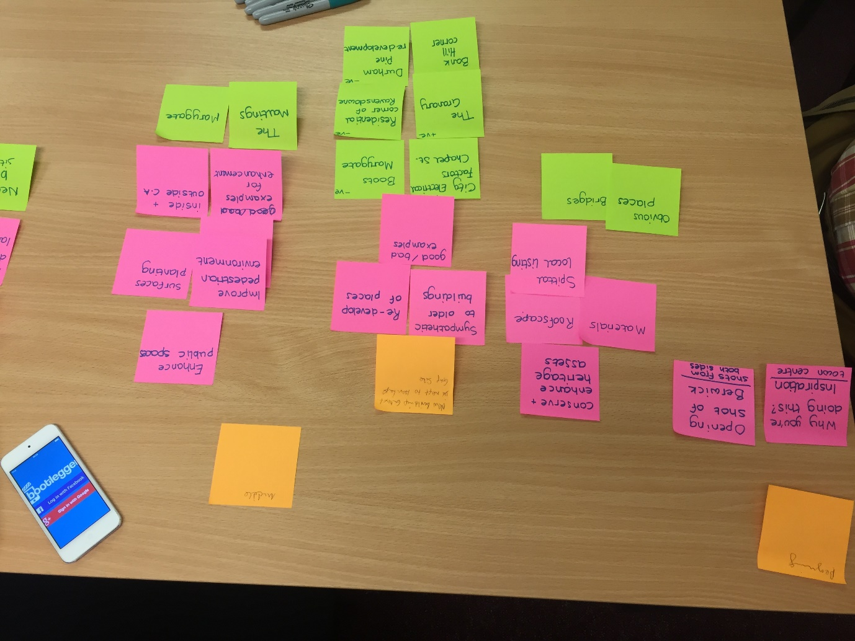
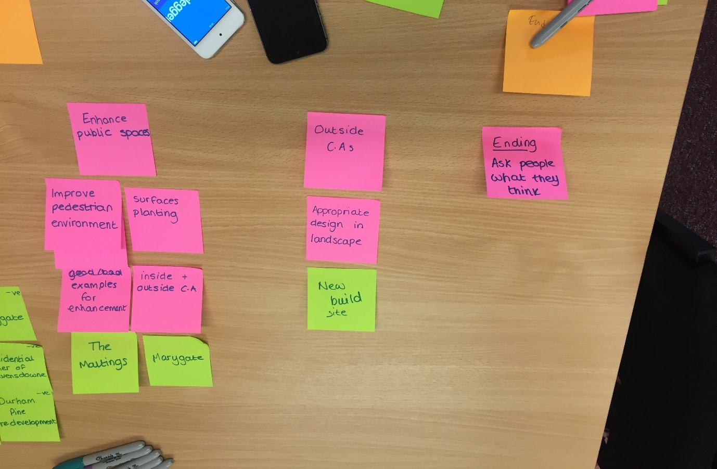
- Their discussion was particularly interesting but they didn’t write much on post-it notes despite prompts from me so I began to scribble down all of the notes.
- The group had much more planned than any of the other groups I had worked with so far and a very clear idea of what they would like to portray.
  - P5: “I think we should stay focused on the streetscape on the main street, it’s too busy.”
- When P7 made suggestions, they were often not met with enthusiasm and the other participants clearly dominated the conversation despite my facilitation.
  - P7: “we could somehow suggest or show that the parking should be removed from the main street. So, instead of people pulling up and parking outside and crowding the main road and the pedestrian areas, all of that is removed”
  - P5: “No, it’s pointless suggesting that. I know the businesses wouldn’t agree to that, they’d fight against it so it’s pointless to consider it.”
- P5 is a dominant character and with her knowledge of planning she tends to overrule others’ opinions if they don’t fit within her prior knowledge of planning.
- After the storyboard was set out and the group could see all of the issues and locations they had talked about and selected, there was some very important conversations:
  - P6: “We need to be careful about what we’re saying and how we’re saying it. Think about it, if we’re sharing this with people, they’ll think we’ve ignored their neighbourhood.”
  - P7: “Yes, we have to remember that we’re supposed to be looking at the whole neighbourhood planning boundary. What do we want to include about that?”
  - P5: “I don’t think we have much information about the rest of the boundary.”
  - P7: “We don’t so what do we do? People will think we’re too focused on the town centre and we’re neglecting everywhere else.”
- It was decided that the group would go out to film, capture the footage and review it before deciding what else they wanted to do or what they had missed.
- All of the group took part in capturing some video but initially, most was done by P7 as he felt most confident with one of the others providing a voiceover.
- When using the app, P7 turned off the graphic overlays, as he felt these were very distracting.
- Despite saying she was not good with technology, P6 became very confident very quickly with the technology and was happy to provide voiceovers and whilst filming.
- This then provided some particularly interesting activity as all of the group were filming in one location but often speaking about different issues or elements of the area.
- P5 and P6 were true to the earlier discussions and their opinions were very set initially, but P7, who had been quiet during earlier discussions, began to tell his own stories and give his own views that didn’t necessarily align with the previous discussion.
- This was often noticed by the others in the group and rather than closing down P7 or correcting him, they were more open to listen than they had been previously.
- After some filming, we took a break in a café and the group naturally revisited their earlier conversations. They began to speak about the purpose of the filming so they could better frame the issues or locations they wanted to cover in the filming
  - P5: “I think we need to use this media as a way to ask other people what they think and what they know. We’ve focused too much on the centre and the people that live in the other neighbourhoods will know more than we do. We could use the video as a way to ask them their opinions”.
- This was a significant change from P5’s earlier attitude to filming and the topics they wanted to cover.
  - P5: “We could use the film to showcase the town centre and we could even show what it was like before from some old photographs.”
  - P6: “I am a little concerned that we’re too focused on the town centre still.”
  - Researcher: “Let’s go back to the purpose of the film. What will it show? Do you want to show something from the whole area or do you want to use it as a way to say to the community, we need your help?”
  - P6: “We could. We could showcase the town centre and then ask for responses about other parts of the neighbourhood.”
- P6 continued to film after the break. P7 had to leave and P5 had an appointment after which she would return and re-join the group.
- Here, P6 led the filming process and captured a lot of footage around the town centre and surrounding streets.
- She visited a neighbour who she knew had a lot of old photos to see if she could video some of them as per their earlier conversation.
- P6 went in to film some of the old photos and thought this could provide a new angle to show before and after videos of the town and this would spark engagement from others.
- P5 met us back at the council offices to review the day and think about the videos going forward
- At the end of the workshop, P5 said:
  - “Thank you for this. It was really good. I thought it would be pointless and I couldn’t see what difference it would make. I’m used to the older ways of planning that I used to do but it was really good”.
- This was a huge change from the scepticism of earlier.
- P6 was keen to continue filming and downloaded the app onto her own phone. She made plans to go out with P5 to capture more footage.

