**Soluble Polystyrene-b-poly (ethylene/butylene)-b-polystyrene Based Ionomer for Anion Exchange Membrane Fuel Cells Operating at 70 °C**

G. Gupta1, K. Scott1, M. Mamlouk1,*

Figure S1: NMR graph of SEBS and Chloromethylated SEBS with the structure of chloromethylated SEBS.

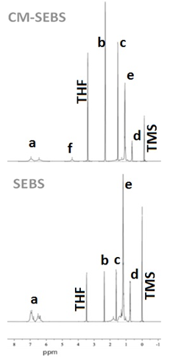

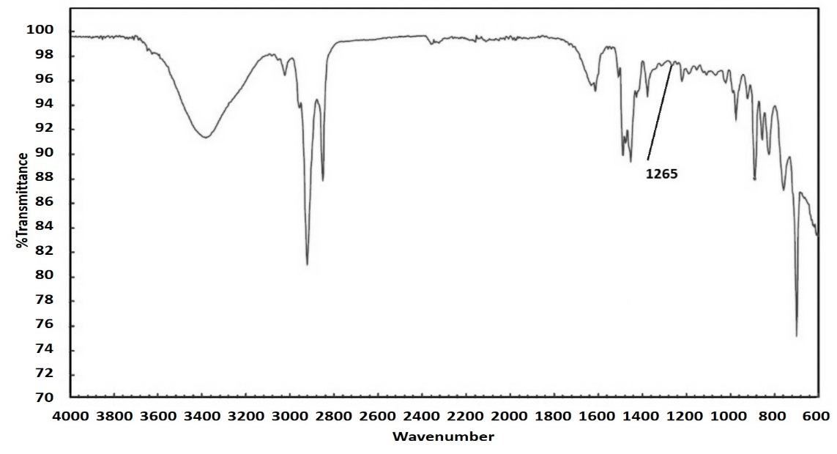

Figure S2: FTIR spectra of the chloromethylated SEBS. (1265 is the chloromethyl peak)

S3: The degree of grafting (DOG) of the membrane was measured from the weights of the membrane before and after gamma irradiation using the following formula:

$DOG\left(\%\right)= \frac{W_{1}-W_{0}}{W_{1}}*100$

where W1 is the weight of the polymer after irradiation and W0 is the weight of the polymer before irradiation.

S4: Calculation of Ion Exchange Capacity

$IEC \left({mmolg}^{-1}\right)=\frac{2*V1*M1*V2}{W}*1000$

Where, V1= Volume of H2SO4 titrated, M1= Molarity of H2SO4 used for titration, V2= Total amount of Chloride Solution, W= Dry weight of the membrane

S5: Calculating of degree of chloromethylation from figure S1

Degree of chloromethylation = $\frac{\frac{Area(f)}{2}}{\frac{Area \left(a\right)+ \frac{Area (f)}{2}}{5}}$

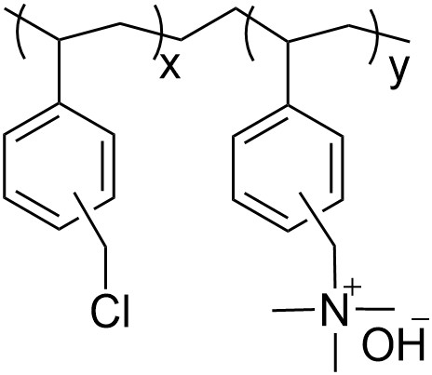

Figure S6: Structure of PVBC-60% (y/x = 60/40)

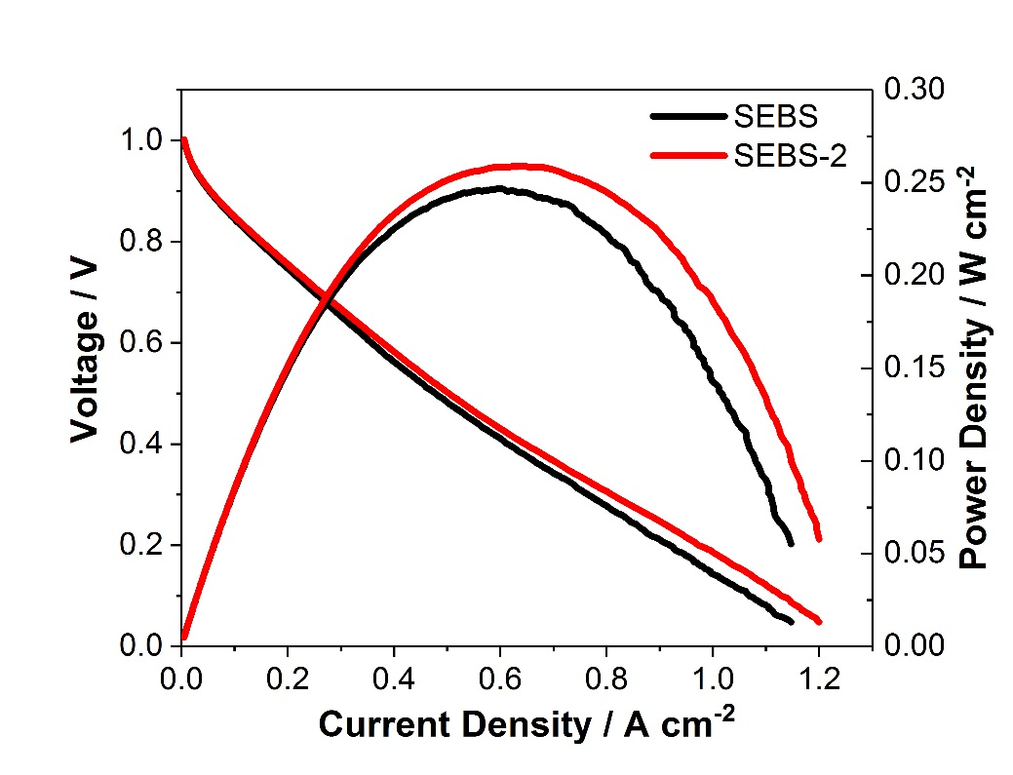

Figure S7: Polarization comparison of fuel cell testing at 50 °C with SEBS ionomer. Area: 1 cm2 Anode: 20% Pt/C, Cathode: 40% Pt/C, Loading: 0.4 mg cm-2, Membrane: LDPE-VBC-TMA-30 µm, Flow rate: 100 mlpm H2, 21% O2, 1 bar back pressure. Anode-100% RH, Cathode- 20% RH

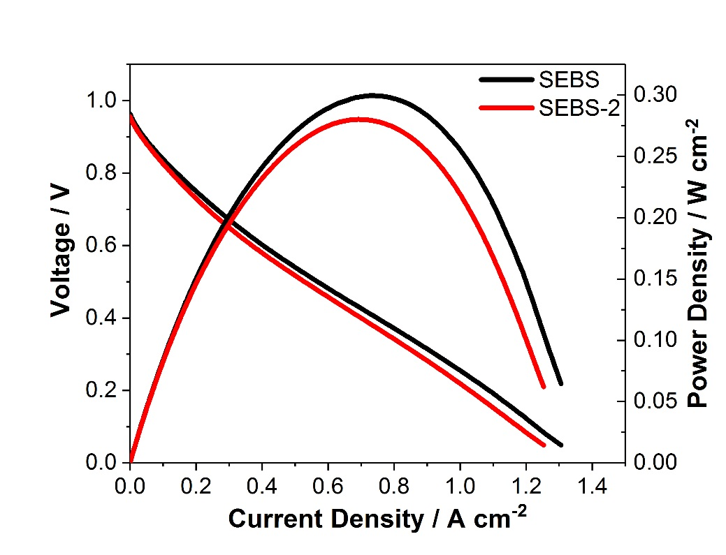

Figure S8: Polarization comparison of fuel cell testing at 70 °C with SEBS ionomer. Area: 1 cm2 Anode: 20% Pt/C, Cathode: 40% Pt/C, Loading: 0.4 mg cm-2, Membrane: LDPE-VBC-TMA-30 µm, Flow rate: 100 mlpm H2, 21% O2, 1 bar back pressure. Anode-100% RH, Cathode- 15% RH.

S8: Calculation of hydrogen crossover current

Hydrogen crossover current was calculated from the cyclic voltammetry graph at the open circuit potential (1V). This was done by calculating the amount of negative current at OCP which has been caused by the oxidation of crossed-over hydrogen at the cathode.