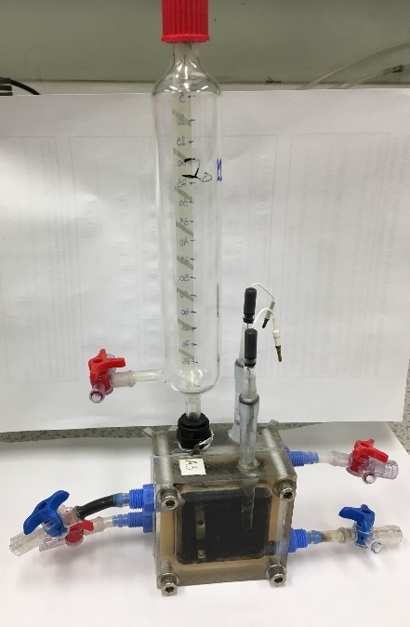

Figure S1 Schematic and the of double-chamber electrochemical cells